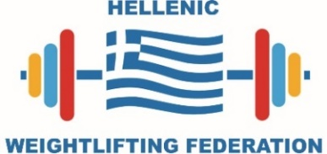

ACCOMMODATION & TRANSPORTATION FORM

The deadline to submit the document is the 2nd April 2022
WEIGHTLIFTING FEDERATION OF | (country name)

№ | Name & Surname  (as per passport, for all team members) | Function | Room type (single/double) | Arrival |  |  | Departure
 |  |  |  | Date | Time | Flight № | Date | Time | Flight №
1
2
3
4
5
6
7
8
9
10
11
12
13
14
15
Hellenic Weightlifting Federation - Local Organizing Committee
Tel: 0030 2109231683, 0030 2109231780, Tel/fax: 0030 2109243875
Address: Olympic Center of Athens, D Build., 37 Kifisias Av., 151 23 Marousi, Greece
Email: 2022JWC@weightlifting.gr

