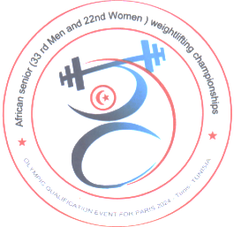

African Senior (33rd Men & 22nd Women) Weightlifting Qualification Championships
11-20/05/2023 /Tunis, Tunisia

FLIGHT SCHEDULE FORM

Country:

No. | Name | Position | Passport No. | Arrival Details  Date, Time | Airline flight No. | Departure Details  Date Time | Airline flight No.
1
2
3
4
5
6
7
8
9
10
11
12
13
14
15
President /Secretary Sign/stamp…………………………………. Date ……………………….

Should be sent to OC and WFA no later than April 11th, 2023

Organising Federation (TUN): Continental Federation (WFA):
E-mail: fthalttn@yahoo.com E-mail: manareddin.eshelli@wfa.com.ly

