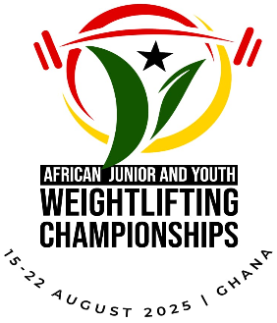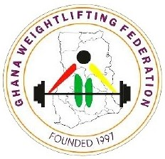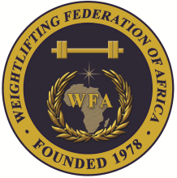

**2025 African Junior and Youth Weightlifting Championships**

**August 15-22, 2025/Accra, Ghana**

**TEAM ACCOMMODATION FORM**

**Country:**

|  |  |  |
| --- | --- | --- |
| Date | Single Room | Double Room |
| Aug. 14, 2025 |  |  |
| Aug. 15, 2025 |  |  |
| Aug. 16, 2025 |  |  |
| Aug. 17, 2025 |  |  |
| Aug. 18, 2025 |  |  |
| Aug. 19, 2025 |  |  |
| Aug. 20, 2025 |  |  |
| Aug. 21, 2025 |  |  |
| Aug. 22, 2025 |  |  |

President or General Secretary

Name:_____________________________ Date:_____________ Signature: _____________

Should be sent to LOC (GHA) and WFA no later than July 17, 2025

**Organising Federation: Continental Federation:**

E-mail: ghanaweightlifting2017@yahoo.com E-mail: [manareddin.eshelli@wfa.com.ly](mailto:manareddin.eshelli@wfa.com.ly)