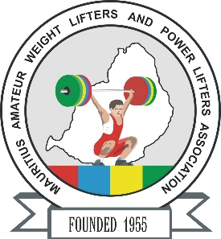

**African Senior (35th Men & 24th Women) Weightlifting Championships**

**20-28/04/2025 /Moka, Mauritius**

**FINAL WOMEN SENIOR ENTRY FORM**

**Country:**

|  |  |  |  |  |  |  |  |
| --- | --- | --- | --- | --- | --- | --- | --- |
| **No.** | **Athlete's name** | | **Date of birth** | | | **Bodyweight Category** | **Entry Total** |
| **First Name** | **Last Name (Capital)** | **DD** | **MM** | **YYYY** |
| **1** |  |  |  |  |  |  |  |
| **2** |  |  |  |  |  |  |  |
| **3** |  |  |  |  |  |  |  |
| **4** |  |  |  |  |  |  |  |
| **5** |  |  |  |  |  |  |  |
| **6** |  |  |  |  |  |  |  |
| **7** |  |  |  |  |  |  |  |
| **8** |  |  |  |  |  |  |  |
| **9** |  |  |  |  |  |  |  |
| **10** |  |  |  |  |  |  |  |
| **11R** |  |  |  |  |  |  |  |
| **12R** |  |  |  |  |  |  |  |

|  |  |  |  |  |  |  |
| --- | --- | --- | --- | --- | --- | --- |
| **No.** | **Official’s name** | | **Date of birth** | | | **Function** |
| **First Name** | **Last Name (Capital)** | **DD** | **MM** | **YYYY** |
| **1** |  |  |  |  |  |  |
| **2** |  |  |  |  |  |  |
| **3** |  |  |  |  |  |  |
| **4** |  |  |  |  |  |  |
| **5** |  |  |  |  |  |  |

**President or General Secretary**

**Name:** **Date:** **Signature:**

Should be sent to OC and WFA respectively no later than March 23rd, 2025

**Organising Federation (MRI): Continental Federation (WFA):**

**E-mail:** mauritius.weightlifting@hotmail.com **E-mail:** [manareddin.eshelli@wfa.com.ly](mailto:manareddin.eshelli@wfa.com.ly)