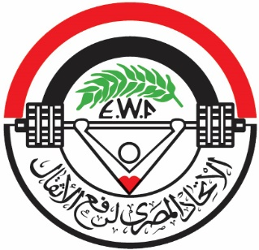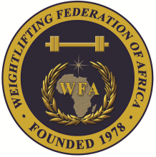

**African Junior and Youth Weightlifting Championships**

**October 26-31, 2023/Cairo, Egypt**

**PRELIMINARY WOMEN YOUTH ENTRY FORM**

**Country:**

|  |  |  |  |  |  |  |  |
| --- | --- | --- | --- | --- | --- | --- | --- |
| No. | **Athlete's name** | | **Date of birth** | | | **Bodyweight Category** | **Entry Total** |
| **Family** | **Given** | **DD** | **MM** | **YYYY** |
| **1** |  |  |  |  |  |  |  |
| **2** |  |  |  |  |  |  |  |
| **3** |  |  |  |  |  |  |  |
| **4** |  |  |  |  |  |  |  |
| **5** |  |  |  |  |  |  |  |
| **6** |  |  |  |  |  |  |  |
| **7** |  |  |  |  |  |  |  |
| **8** |  |  |  |  |  |  |  |
| **9** |  |  |  |  |  |  |  |
| **10** |  |  |  |  |  |  |  |
| **11** |  |  |  |  |  |  |  |
| **12** |  |  |  |  |  |  |  |
| **13** |  |  |  |  |  |  |  |
| **14** |  |  |  |  |  |  |  |
| **15** |  |  |  |  |  |  |  |
| **16** |  |  |  |  |  |  |  |
| **17** |  |  |  |  |  |  |  |
| **18** |  |  |  |  |  |  |  |
| **19** |  |  |  |  |  |  |  |
| **20** |  |  |  |  |  |  |  |

|  |  |  |  |  |  |  |
| --- | --- | --- | --- | --- | --- | --- |
| No. | **Official’s name** | | **Date of birth** | | | **Function** |
| **Family** | **Given** | **DD** | **MM** | **YYYY** |
| **1** |  |  |  |  |  |  |
| **2** |  |  |  |  |  |  |
| **3** |  |  |  |  |  |  |
| **4** |  |  |  |  |  |  |
| **5** |  |  |  |  |  |  |

President or General Secretary

Name:_____________________________ Date:_____________ Signature: _____________

Should be sent to LOC and WFA no later than August 26, 2023

**Organising Federation: Continental Federation:**

E-mail: weightlifting_egy@yahoo.com E-mail: [manareddin.eshelli@wfa.com.ly](mailto:manareddin.eshelli@wfa.com.ly)