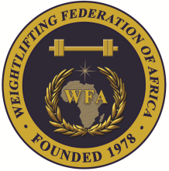
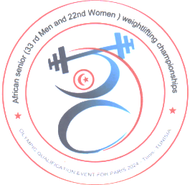
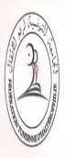
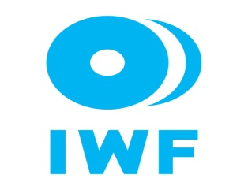

African Senior (33rd Men & 22nd Women) Weightlifting Qualification Championships
11-20/05/2023 /Tunis, Tunisia

MEDIA FORM

Last Name………………………………………… Name…………………………………..
Nationality………………………………………… Employee………………………………
Address……………………………………………. Province ………………………………..
Identification/Passport No. ..…………………….. City……………………………...............

□ Journalist □ News Agency □ Daily newspape
□ Sport Magazine □ Photographer □ Radio Reporter
□ TV Reporter □ Other: ………………………………………

What communication type you will use?
□ Telephone □ Fax □ E-mail □ Other: ………………………….
Departure
Date/Time: ____________________

Flight Number: ___________________

Signature: _______________________
Arrival
Date/Time:_______________________

Flight Number: ___________________

Signature: _______________________

There are 2 options for Media representatives:

Pay Participation Fee with arrangement of accommodation at the El Mouradi Hotel Gammarth with full board i.e. meals, airport transfers and media credentials from the Local Organizing Committee (LOC).

Single Room: USD $140 per person, per day.
Single Room: USD $130 per person, per day.

Pay an Entry Fee Only (USD $ 100/person) without any arrangement from the LOC Advance Approval Required.

President or General Secretary

Name:_____________________________ Date:_____________ Signature: _____________

Should be sent to OC and WFA no later than April 11th, 2023

Organising Federation (TUN): Continental Federation (WFA):
E-mail: fthalttn@yahoo.com E-mail: manareddin.eshelli@wfa.com.ly

