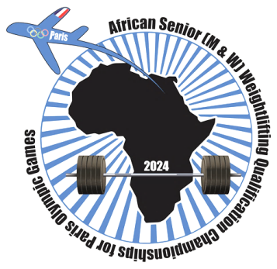

African Senior (34th Men & 23rd Women) Weightlifting Qualification Championships
02-10/02/2024 /Ismailia, Egypt

PRELIMINARY MEN SENIOR ENTRY FORM
Country:

No. | Athlete's name |  | Date of birth |  |  | Bodyweight Category | Entry Total
 | Given | Family | DD | MM | YYYY
1
2
3
4
5
6
7
8
9
10
11
12
13
14
15
16
17
18
19
20

No. | Official’s name |  | Date of birth |  |  | Function
 | Given | Family | DD | MM | YYYY
1
2
3
4
5
President or General Secretary

Name: Date: Signature:

Should be sent to OC and WFA no later than December 04th, 2023

Organising Federation (EGY): Continental Federation (WFA):
E-mail: weightlifting_egy@yahoo.com E-mail: manareddin.eshelli@wfa.com.ly

