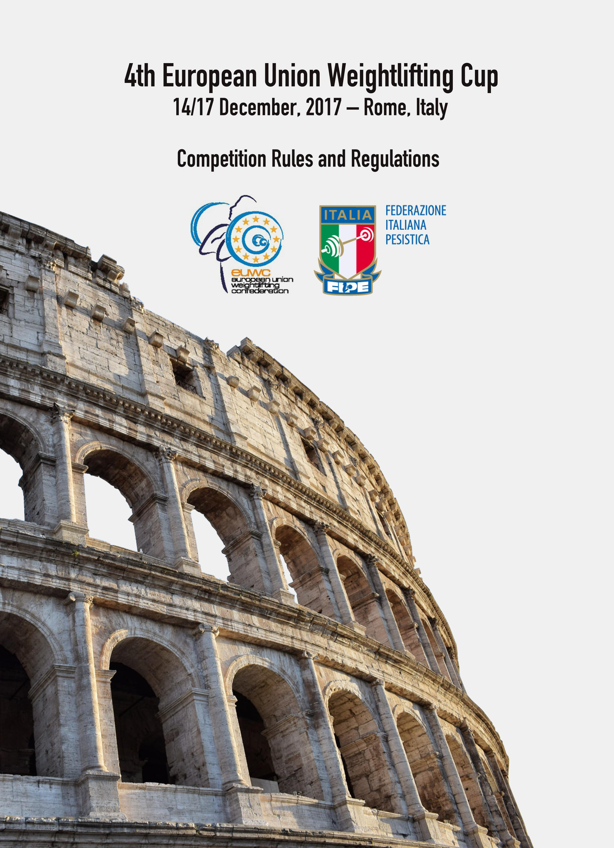
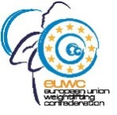
4th EUROPEAN UNION WEIGHTLIFTING CUP
14/17 December, 2017 – Rome, ITALY

COMPETITION RULES AND REGULATIONS
Competition will be held in accordance with EUWC rules.
The team should be composed of a maximum of 6 athletes, 3 males and 3 females:
- 1 female lifter and 1 male lifter Under 15 – not younger than 13 years of age;
- 1 female lifter and 1 male lifter Under 17 – not younger than 16 years of age;
- 1 female lifter and 1 male lifter Under 20 – not younger than 18 years of age.
Results will be calculated on the Sinclair form.
AWARDS
Gold, Silver and Bronze medals will be awarded to the first three athletes in the Snatch, Clean & Jerk and the Total in each bodyweight category.
Team Trophy – the highest six ranked Nations (by Sinclair points for the female + male lifters).
Best Lifter trophies will be awarded in both men’s and women’s events.
ENTRIES
Preliminary Entry Form must be received by the Organizing Committee before 15th October ;
Final Entry and Accommodation & Transportation Forms must be received by the Organizing Committee before 15th November.
COMPETITION AND ACCOMMODATION VENUE
C.S.O.E. – Italian Army Olimpic Sport Center - Via degli Arditi, 1 - 00143 Rome - Italy
All athletes and team members will be accommodated full board.
The accreditation will take place at C.S.O.E. – Italian Army Olimpic Sport Center.

TRANSPORTATION
The C.S.O.E. is easily accessible from the Leonardo da Vinci International Fiumicino Airport and the Ciampino Airport.
The Organizing Committee will provide transportation from/to airports to the accommodation and competition venue.
FINAL CONDITIONS
The accommodation fee per person full board is:
- Single room - 105,00 euro per person per day;
- Double room – 85,00 euro per person per day.
No entry fee. No doping control fee.
PAYMENT
The Accommodation Fees should be paid by bank transfer to:
BANK DETAILS
ACCOUNT NAME : Federazione Italiana Pesistica
ADDRESS: Viale Tiziano,70 - 00196 Rome - Italy
REASON FOR PAYMENT: EUCUP 2017 (Nation Name)
IBAN: IT83Y0100503309000000010130
SWIFT BIC: BNLIITRR
BANK CODE: BNLI
COUNTRY CODE: IT
LOCATION CODE: R1
BRANCH CODE: BIZ
Please send us a proof of payment not later than 10 December 2017 by email to eucup2017@federpesistica.it .

VISA TO ITALY
European Union countries do not require a visa to Italy.
All other participants must contact the Italian embassy in their own country to verify if a visa is needed.
INSURANCE
National Federations must undertake full moral and financial responsibilities for their delegates regarding their health in case of accidents or damages.
DOPING CONTROL
The EUWC applies the IWF Anti-Doping Policy.
BARBELL
Eleiko barbells will be used in competition and training.
TECHNICAL OFFICIALS
The participating federations must delegate a Technical Official for the competition, category I or II and whit IWF licence paid. (to be confirmed)
ORGANIZING COMMITTEE CONTACT:
ITALIAN WEIGHTLIFTING FEDERATION
Viale Tiziano, 70 – 00196 Rome (Italy)
Tel. +39.068797.3016/3017
Fax. +39.068797.3030
Email: eucup2017@federpesistica.it
Web: www.federpesistica.it
EUWC CONTACT:
Mr. Barbone Michele - EUWC General Secretary Mr. Jesmond Caruana – EUWC Vice President
Email: michele.barbone2007@libero.it Email: maltese@maltanet.net

