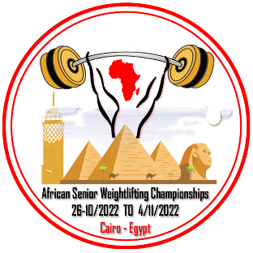
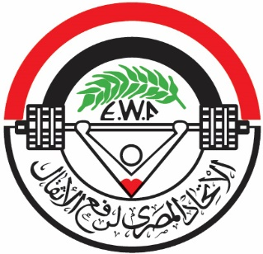
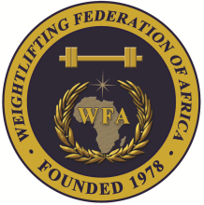

African Senior (32nd Men & 21st Women) Weightlifting Championships
26/10-04/11/2022 /Cairo, Egypt

TEAM ACCOMMODATION FORM

Country:

Date | Single Room | Double Room | Triple
Oct. 25-2022
Oct. 26-2022
Oct. 27-2022
Oct. 28-2022
Oct. 29-2022
Oct. 30-2022
Oct. 31-2022
Nov. 01-2022
Nov. 02-2022
Nov. 03-2022
Nov. 04-2022
Nov. 05-2022

President or General Secretary

Name:_____________________________ Date:_____________ Signature: _____________

Should be sent to OC and WFA no later than September 26, 2022

Organising Federation: Continental Federation:
E-mail: weightlifting_egy@yahoo.com E-mail: manareddin.eshelli@wfa.com.ly

