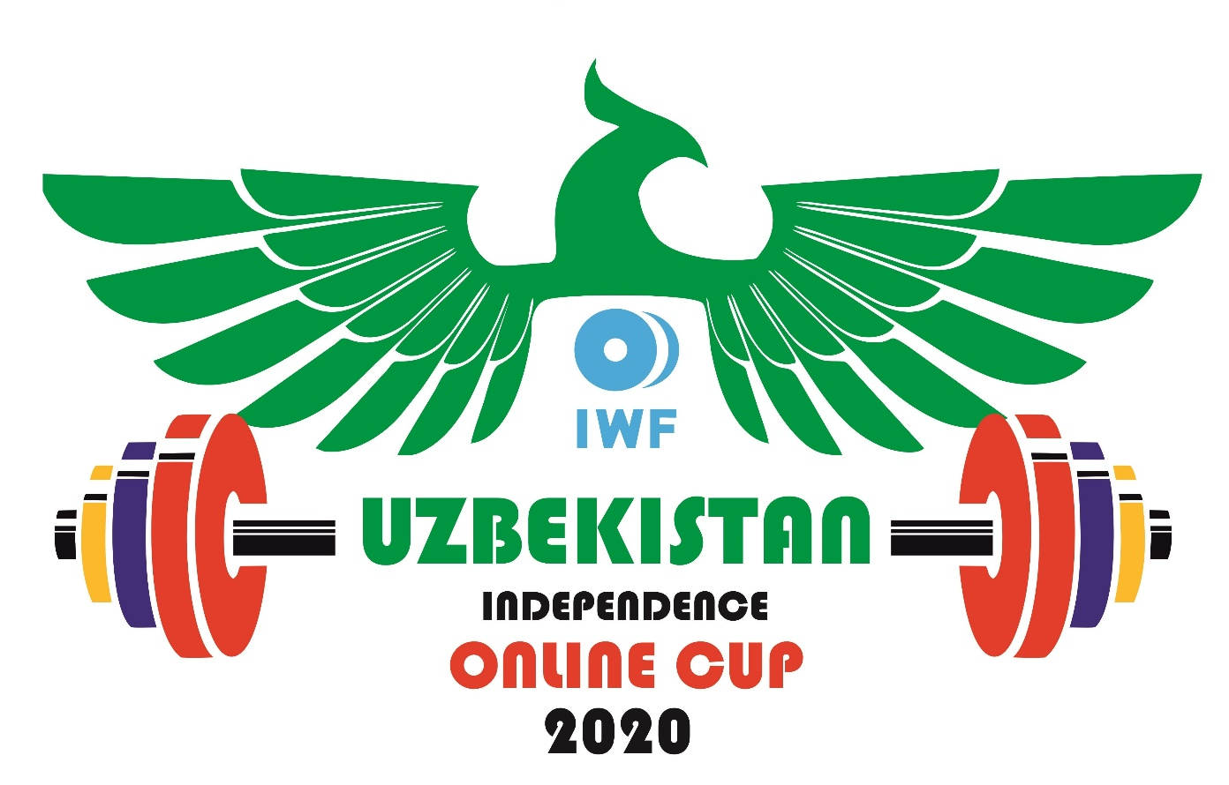

REGULATION

INTRODUCTION

In the current global health crisis due to COVID-19, our sport continues to adapt. The Weightlifting Federation of the Republic of Uzbekistan and our strategic partner, the National Olympic Committee of Uzbekistan, are therefore pleased to announce the 1st Online International Weightlifting Cup dedicated to the Independence Day of Uzbekistan, inviting top athletes from around the world to participate in Asia’s first international, live online weightlifting competition.

REGULATIONS

1. DATE / PLACE
August 28~30, 2020 / HOME GYM or TRAINING FACILITY

2. COMPETITION AND TRAINING VENUE
The objective of the competition is to provide a safe competition opportunity for the athletes training at home without the need to assemble for the competition.

STAY SAFE!
Please be sure to follow your national health and safety regulations!

Therefore, athletes can compete at HOME (e.g., garage, terrace, garden, etc.) or, where permitted, at your TRAINING FACILITY (e.g., national training center, local club or gym, etc.).

3. TERMS AND CONDITIONS OF PARTICIPATION
The 1st Online International Weightlifting Cup dedicated to the Independence Day of Uzbekistan is an invitational weightlifting competition. The Organizing Committee will invite 100 athletes from all over the World.

4. FINANCIAL CONDITIONS
Participation is FREE. This competition will have NO Participation or Entry Fee.

4A. PHOTO REQUIRED
You must send a photo headshot (passport-style in JPEG format with the best resolution possible) including your Name and the Country you are representing to [uzbek_weightlifting@yahoo.com]

4B. EMAIL ADDRESS REQUIRED
The athlete and the coach must provide a valid email address, which will be used as a point of contact throughout the competition. Athletes may use their federation/association’s email address as a contact for the online competition.

5. COMPETITION REGULATION
The event will follow the IWF Technical and Competition Rules & Regulations (TCRR), with the following exceptions:

- No competition platform required
- Certain exceptions to Competition-certified equipment permitted (see section 9 below)
- Changes to the calling order (competition format)
- Operation of the timing clock
- Composition of Technical Officials involved
- Down Signal exception as per “The Competition Rules for the Two Lifts” (see #5A)

As this competition will not strictly adhere to the TCRR, the IWF / AWF will not officially recognize the results and new record(s).

Athletes must wear the standard weightlifting costume and sport footwear (see IWF TCRR 4).

5A. SPECIAL COMPETITION RULES FOR THE TWO LIFTS

- THE SNATCH
The barbell is centered horizontally on the center of the competition platform. The athlete takes the start position behind the barbell. The athlete grips the barbell and bends at the knees. The barbell is gripped, palms downward and pulled in a single movement from the platform to the full extent of both arms above the head, while either splitting or bending the legs. During this continuous movement upward the barbell should remain close to the body and may slide along the thighs. No part of the body other than the feet may touch the platform during the execution of the Snatch. The athlete may recover in his/her own time, either from a split or a squat position. The lifted weight must be maintained in the final motionless position, with both arms and legs fully extended and feet on the same line and parallel to the plane of the trunk and the barbell. At this point the athlete must be stationary and in control of the barbell before the lift is deemed to be complete.

The athlete at his/her own discretion decides if the lift is complete according to the rule as stated above. Then lowers the barbell in front of the body releasing his/her grip on the barbell only after it has passed the level of the shoulders.

- THE CLEAN & JERK

The First Part, the Clean:
The barbell is centered horizontally on the center of the competition platform. The athlete takes the start position behind the barbell. The athlete grips the barbell and bends at the knees. The barbell is gripped, palms downward and pulled in a single movement from the platform to the shoulders, while either splitting or bending the legs. During this continuous movement upward the barbell should remain close to the body and the barbell may slide along the thighs. The barbell must not touch the chest before it stops at the final position either on the clavicles, chest or on fully bent arms. The athlete's feet must return to the same line and the legs must be fully extended before starting the Jerk. No part of the body other than the feet may touch the platform during the execution of the Clean. The athlete may recover in his/her own time and must finish with the feet on the same line and parallel to the plane of the trunk and the barbell.

The Second Part, the Jerk:

The athlete must become motionless with the knees fully extended before starting the Jerk. The athlete bends and dynamically extends the legs and arms simultaneously to move the barbell upward in one motion to the full extent of the arms, while either splitting or bending the legs. The athlete returns his/her feet to the same line parallel to the plane of the trunk and the barbell with his/her arms and legs fully extended. At this point the athlete must be stationary and in control of the barbell before the lift is deemed to be complete.

The athlete at his/her own discretion decides if the lift is complete according to the rule as stated above. Then lowers the barbell in front of the body releasing his/her grip on the barbell only after it has passed the level of the shoulders.

- ATHLETE’S RESPONSIBILITY
It is the sole responsibility of the athlete to complete the lift in accordance with the rules of the Snatch and the Clean and Jerk as stated above and to the satisfaction of the on-duty Technical Officials.

- TOUCHING THE BARBELL WITH FOOTWEAR IS NOT ALLOWED
The athlete may not touch the Barbell with his/her footwear at any time prior, during and after the lift. If the athlete touches the Barbell with their footwear it will be immediately No Lift or a reversal from a Good Lift to a No Lift after successfully completing a Good Lift.

6. ELIGIBILITY
The event is organized for Senior weightlifters invited by the Organizing Committee. Participating athletes must be 15 years of age and over (year of birth 2005 or earlier). A maximum of 100 athletes may participate.

All Athletes participating at the 1st Online International Weightlifting Cup dedicated to the Independence Day of Uzbekistan shall successfully complete the WADA ADeL online course for Athletes (ALPHA) before the competition.

The course can be found at the following link: https://adel.wada-ama.org/

Just as in the case of the IWF ILiftClean platform, Athletes shall register at the site, watch the videos, and successfully complete the quiz at the end to receive the certificate.

In case Athletes have any problem with the registration process, please contact WADA at adel@wada-ama.org and the IWF at education@iwfnet.net.

7. DOPING CONTROL
Athletes are subject to doping control in accordance with the IWF Anti-Doping Policy.

8. EVENT CATEGORIES
MEN: 67kg, 89kg, 102kg, 109kg, +109kg
WOMEN: 55kg, 59kg, 71kg, 81kg, +87kg
Each team can present only one (male/female) athlete per category.
It means maximum 5 male and 5 female athletes from per country.

9. SPORT EQUIPMENT
IWF-approved colorful barbell to be used during the competition.

If you are not able to use an IWF-approved barbell, please contact the Organizing Committee by email: [uzbek_weightlifting@yahoo.com]

10. AWARDS
A) MEDALS
Gold, silver, and bronze virtual medals will be awarded in the Snatch, the Clean & Jerk, and the Total in each bodyweight category.

B) CASH PRIZES
Cash prizes will be awarded in each weight category for BEST TOTAL as follows:
- 1st Place - $2000 USD
- 2nd Place - $1000
- 3rd Place - $500

C) CERTIFICATES OF PARTICIPATION
All participating athletes will receive an official certificate after the event.

11. PROCEEDINGS OF THE EVENT
ENTRIES
Invited Athletes / Member Federations (MF) are requested to confirm their participation by August 7, 2020

WEIGH-IN
Athletes must submit a photograph (JPEG format) showing the athlete on the scale and showing the bodyweight. The athletes’ bodyweight and the first attempts (Snatch and C&J) must be sent from an authorized MF contact (email, WhatsApp, etc.) during the official weigh-in time (see IWF TCRR 6.4.1). Please see the Sample Weigh-In Form attached to the end of these Regulations for reference.

VERIFICATION OF FINAL ENTRIES (VFE)
Athletes may modify their bodyweight category and entry totals on the Verification of Final Entries Day/Meeting. The deadline is August 21, 2020 at 23:59 (11:59pm) in the Tashkent, Uzbekistan time zone.

COURSE OF COMPETITION
The competition will be conducted by ‘modified’ Round Robin with special rules:

- Unlike the IWF TCRR, all attempts will be taken by rounds. This means that all first attempts (1st round) have to be taken one by one, starting with the lowest weight, and increasing.
After all first attempts are completed, all second attempts (2nd round) have to be done in the same way, which will be followed by the 3rd attempts (3rd round).
- After the introductions of the athletes and officials there will be a five (5) minute period before the competition begins (including the modification period in the last two (2) minutes).
- Two (2) minutes before each round there will be a Modification Period (2 changes are allowed) where the athletes can modify their next weights, which must be done before the start of each round through the ZOOM application (chat function). This means that NO modification is allowed during the course of a round.
- One (1) minute is allocated to each athlete between the (automatic) calling and the beginning of the attempt. The timing clock starts automatically after the database is updated.
- There is a ten (10) minute break (including the modification period in the last two (2) minutes) after the Snatch portion to allow the athletes to warm up for the Clean & Jerk.
- The event follows the IWF TCRR including classification. See the explanatory table attached.

The competition will feature a commentator instead of a speaker!

TECHNICAL OFFICIALS
The event will be conducted by 4 referees simultaneously:

- 3 main referees and 1 reserve referee (serving also as Timekeeper to stop the clock).

However, the decision of the reserve referee will be considered only if one of the main referees’ decision is missing.

There will be no Jury or possibility to challenge the decision of the referees.

ONLINE PLATFORM OF THE COMPETITION
The competition will be conducted with the ZOOM online application connected to the IWF Technology and Information System (TIS).

A LAN connection is highly recommended, as low bandwidth over wireless can cause synchronization issues.

12. TECHNICAL REQUIREMENTS

- Good quality camera shall be used (preferably HD).
- Camera shall be located directly in front of the athlete.
- Camera shall be located 3~4 meters from the athletes’ start position at ~1 meter height ensuring that the athlete and the barbell are fully visible in the complete / finishing position.

13. BROADCAST
The competition shall be broadcasted live on the IWF’s YouTube channel and / or Facebook LIVE.

14. INSURANCE
All participating Federations must undertake full moral and financial responsibility of their registered athletes regarding their health and wellness and in case of accidents or damages.

15. TIMELINE
Entries August 7, 2020

Final Regulation August 14, 2020

Verification of Final Entries Day/Meeting August 21, 2020 (reference #11 VFE above)

Rehearsal August 22, 2020

Connectivity Tests August 24-25, 2020

ITO Seminar August 26, 2020 (7:00am Tashkent, Uzbekistan)

Athletes’ and Coaches’ Seminar August 27, 2020 (7:00am Tashkent, Uzbekistan)

Competition August 28~29, 2020

16. ORGANIZING COMMITTEE
[The Weightlifting Federation of the Republic of Uzbekistan will complete the list of the Organizing Committee. We recommend including the following individuals on the list:

Mr. Shakhrillo Makhmudov
Mr. Nicu Vlad
Mr. Jose Quinones
Ms. Reiko Chinen
Mr. Pedro Sanchez
Mr. Craig Walker
Mr. Joseph Triolo
Mr. Richard Mason
Mr. Stuart Bowen
Mr. Veras Zoltan
Mr. Bahtiyor Abdukarimov
Ms. Zukhra Abdullaeva
Mr. Azamat Sharipov
Mr. Olim Makhmudov

Contact E-Mail: [uzbek_weightlifting@yahoo.com]
WhatsApp contacts:+998998932828 (Azamat Sharipov)
+998998981785 (Bahtiyor Abdukarimov)

PRELIMINARY TIMETABLE
(GMT+5 = Tashkent Time)
DATE/TIME |  | WEIGH-IN | ACTIVITY
August 28  Friday | 10.00-12.00 | 08:00-09:00 | Women’s 55kg
 | 14.00-16.00 | 12:00-13:00 | Women’s 59kg
 | 18.00-20.00 | 16:00-17:00 | Women’s 71kg
August 29  Saturday | 08.00-10:00 | 06:00-07:00 | Men’s 67kg
 | 10.00-12.00 | 08:00-09:00 | Women’s 81kg
 | 14.00-16.00 | 12:00-13:00 | Women’s +87kg
 | 18.00-20.00 | 16:00-17:00 | Men’s 89kg
August 30  Sunday | 10.00-12.00 | 08:00-09:00 | Men’s 102kg
 | 14.00-16.00 | 12:00-13:00 | Men’s 109kg
 | 18.00-20.00 | 16:00-17:00 | Men’s +109kg
Please note that the competition program is subject to changes depending on the entries.

August 28, 2020

SAMPLE ENTRY FORM

COUNTRY:_______________________________________
MEN:

N° | Athlete’s Name |  | Date of Birth |  |  | Cat. | Total | EMAIL AD.
 | Family | Given | Day | Month | Year
01
02
03
04
05
-----------------------------------------------------------------------------------------------------------------
WOMEN:

N° | Athlete’s Name |  | Date of Birth |  |  | Cat. | Total | EMAIL AD.
 | Family | Given | Day | Month | Year
01
02
03
04
05

Date/Time:

Signature:

PLEASE, SEND THE COMPLETED FORM WITH ATHLETE’S PHOTOS

ORGANIZING COMMITTEE
Contact E-Mail : [uzbek_weightlifting@yahoo.com]

August 28, 2020

SAMPLE WEIGH-IN FORM

M__kg
W__-W__kg

WEIGH-IN: August 28, 2020, 08:00 - 09:00
COMPETITION: August 28, 2020, 10:00

Name | Country  Code | DoB | Body  weight | BW  Cat. | ENTRY TOTAL | 1st Attempt  SNATCH | 1st  Attempt  CLEAN&JERK

Date/Time:

Signature:

PLEASE, SEND THE COMPLETED FORM IMMEDIATELY AFTER THE WEIGH-IN HAS FINISHED (BY ATTACHING THE PHOTO OF PROCESS OF WEIGH-IN).

ORGANIZING COMMITTEE
Contact E-Mail : [uzbek_weightlifting@yahoo.com]
WhatsApp contact :+998998932828 (Azamat Sharipov)

