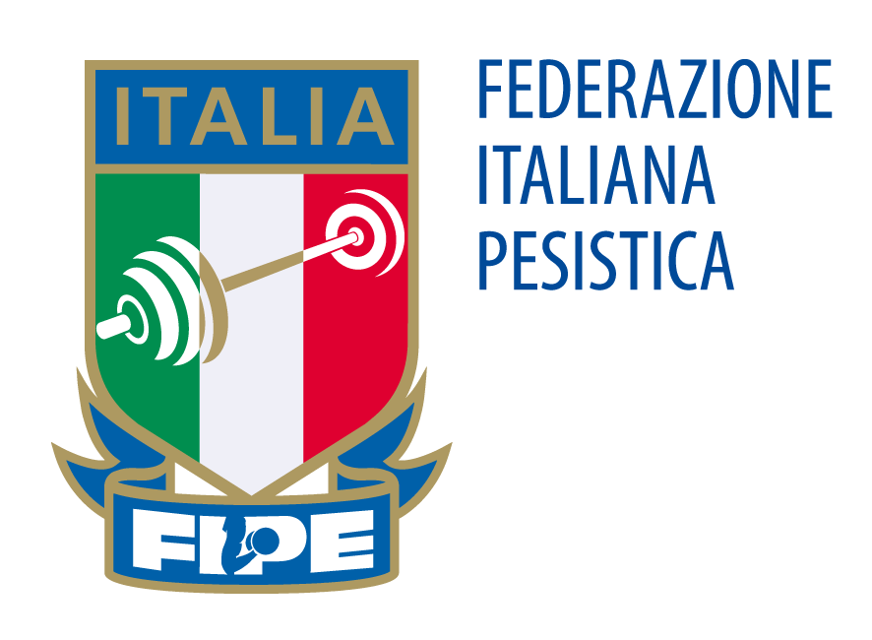

4th EUROPEAN UNION CUP
14/17 December, 2017 – Rome, ITALY

ITALIAN WEIGHTLIFTING FEDERATION ORGANIZING COMMITTEE
V.le Tiziano 70 -00196 Roma
Tel. +39.06.8797.3016/3017 Fax +39.06.8797.3030

Email: eucup2017@federpesistica.it

FINAL ENTRY FORM
This Form must be returned by 15th November 2017
(Please type)

National Weightlifting Federation/Association of:

______________________________________

Nº | Athlete’s Name & Surname | Date of Birth | Cat. | Gender | Best Total | ARRIVAL |  |  | DEPARTURE
 |  |  |  |  |  | Flight Nº | Date | Time | Flight Nº | Date | Time
1.
2.
3.
4.
5.
6.
7.R
8.R

Nº | Official’s Name & Surname | Date of Birth | Position | Arrival |  |  | Departure
 |  |  |  | Flight Nº | Date | Time | Flight Nº | Date | Time
1.
2.
3.
4.
5.

Date: __________________________________ Signature: __________________________________

