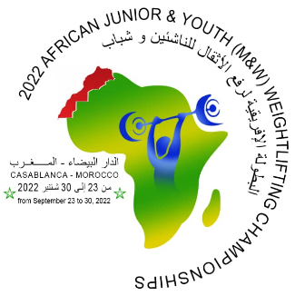
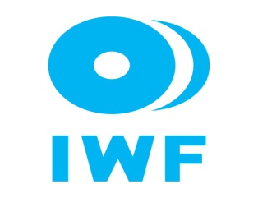
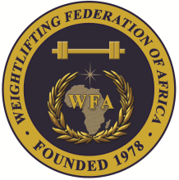

African Junior and Youth Weightlifting Championships
September 23-30, 2022/Casablanca, Morocco

PRELIMINARY MEN JUNIOR ENTRY FORM
Country:

No. | Athlete's name |  | Date of birth |  |  | Bodyweight Category | Entry Total
 | Family | Given | DD | MM | YYYY
1
2
3
4
5
6
7
8
9
10
11R
12R

No. | Official’s name |  | Date of birth |  |  | Function
 | Family | Given | DD | MM | YYYY
1
2
3
4
5

President or General Secretary

Name:_____________________________ Date:_____________ Signature: _____________

Should be sent to OC and WFA no later than July 01, 2022

Organising Federation: Continental Federation:
E-mail: frmhmaroc@gmail.com E-mail: manareddin.eshelli@wfa.com.ly

