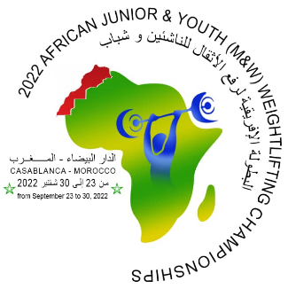
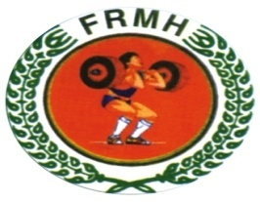
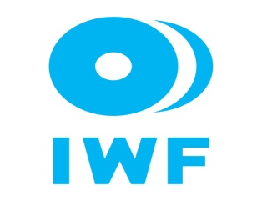
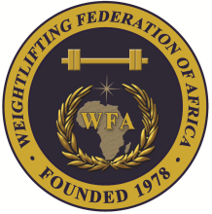

African Junior and Youth Weightlifting Championships
September 23-30, 2022/Casablanca, Morocco

TEAM ACCOMMODATION FORM

Country:

Date | Single Room | Double Room
Sep. 23-2022
Sep. 24-2022
Sep. 25-2022
Sep. 26-2022
Sep. 27-2022
Sep. 28-2020
Sep. 29-2022

President or General Secretary

Name:_____________________________ Date:_____________ Signature: _____________

Should be sent to OC and WFA no later than September 12, 2022

Organising Federation: Continental Federation:
E-mail: frmhmaroc@gmail.com E-mail: manareddin.eshelli@wfa.com.ly

