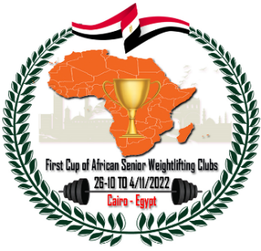
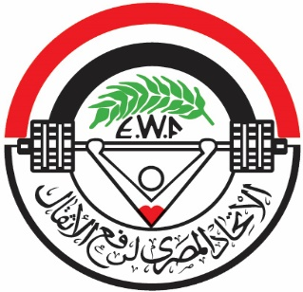
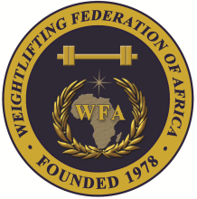

1st Cup of African Senior (Men & Women) Weightlifting Clubs
26/10-04/11/2022 /Cairo, Egypt

PRELIMINARY WOMEN ENTRY FORM

Name of Club : Country :

No. | Athlete's name |  | Date of birth |  |  | Bodyweight Category | Entry Total
 | Family | Given | DD | MM | YYYY
1
2
3
4
5
6R
7R
No. | Official’s name |  | Date of birth |  |  | Function
 | Family | Given | DD | MM | YYYY
1
2
3
4
5

Name of Club’s Chair: Signature:

Date: Stamp:

Name of National Federation’s President or General Secretary:

Date: Signature: Stamp:

Should be sent to OC and WFA no later than August 26, 2022

Organising Federation: Continental Federation:
E-mail: weightlifting_egy@yahoo.com E-mail: manareddin.eshelli@wfa.com.ly

