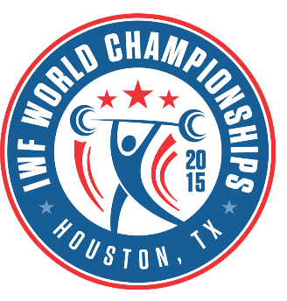
2015 IWF World Weightlifting Championships
Houston, USA

MEDIA ACCREDITATION FORM
Surname: _____________________________________
Name: _____________________________________
AIPS No: _____________________________________
M F
Date of Birth: _____________________________________
Nationality: _____________________________________
Email: ___________________________________________
Name of the EDITORIAL OFFICE: ___________________________________________
Complete address of the editorial office: _______________________________________________________________________
Phone: ______________________________________________________
Email: ______________________________________________________
FUNCTION
Agency TV
Newspaper Photographer
Radio Online
Other _____________________________________________

ARRIVAL
Date: ____________ Time: ____________ Place: ____________

DEPARTURE
Date: ____________ Time: ____________ Place: ____________

The MEDIA ACCREDITATION FORM should be returned by October 19th 2015 to
International Weightlifting Federation Houston Organizing Committee
Tel: +3613530530, Fax: +3613530199 Tel: 713-308-5916, Fax: 713-308-5959
E-mail: lilla.rozgonyi@iwfnet.net E-mail: SBlanton@houstonsports.org
Looking forward to seeing you in Houston!

