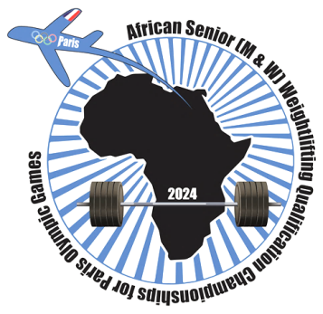
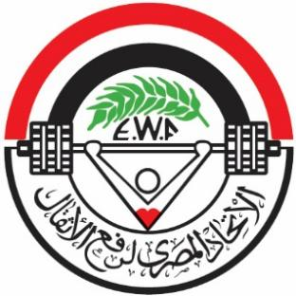
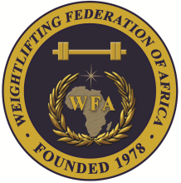

African Senior (34th Men & 23rd Women) Weightlifting Qualification Championships
02-10/02/2024 /Ismailia, Egypt

TEAM ACCOMMODATION FORM

Country:

Date | Single Room | Double Room
February 02, 2024
February 03, 2024
February 04, 2024
February 05, 2024
February 06, 2024
February 07, 2024
February 08, 2024
February 09, 2024

President or General Secretary

Name: Date: Signature:

Should be sent to OC and WFA no later than January 04th, 2024

Organising Federation (EGY): Continental Federation (WFA):
E-mail: weightlifting_egy@yahoo.com E-mail: manareddin.eshelli@wfa.com.ly

