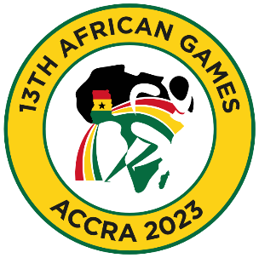

13th African Games
March 09 to 15, 2024 / Accra, Ghana

PRELIMINARY WOMEN SENIOR ENTRY FORM

Country:

No. | Athlete's name |  | Date of birth |  |  | Bodyweight Category | Entry Total
 | Given | Family | DD | MM | YYYY
1
2
3
4
5
6
7
8
9
10

No. | Official’s name |  | Date of birth |  |  | Function
 | Given | Family | DD | MM | YYYY
1
2
3
4
5
President or General Secretary

Name: Date: Signature:

Should be sent to GHA & WFA no later than January 10th, 2024

Organising Federation (GHA): Continental Federation (WFA):
E-mail: ghanaweightlifting2017@yahoo.com E-mail: manareddin.eshelli@wfa.com.ly

