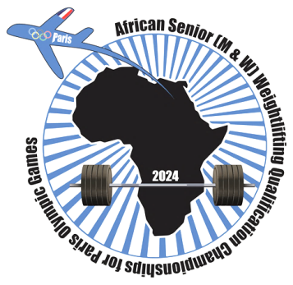

African Senior (34th Men & 23rd Women) Weightlifting Qualification Championships
02-10/02/2024 /Ismailia, Egypt

FINAL MEN SENIOR ENTRY FORM
Country:

No. | Athlete's name |  | Date of birth |  |  | Bodyweight Category | Entry Total
 | Given | Family | DD | MM | YYYY
1
2
3
4
5
6
7
8
9
10
11R
12R

No. | Official’s name |  | Date of birth |  |  | Function
 | Given | Family | DD | MM | YYYY
1
2
3
4
5

President or General Secretary

Name: Date: Signature:

Should be sent to OC and WFA no later than January 04th, 2024

Organising Federation (EGY): Continental Federation (WFA):
E-mail: weightlifting_egy@yahoo.com E-mail: manareddin.eshelli@wfa.com.ly

