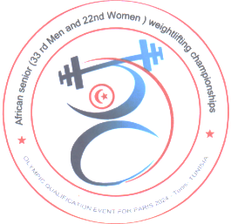
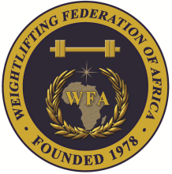

African Senior (33rd Men & 22nd Women) Weightlifting Qualification Championships
11-20/05/2023 /Tunis, Tunisia

TEAM ACCOMMODATION FORM

Country:

Date | Single Room | Double Room
May 11, 2023
May 12, 2023
May 13, 2023
May 14, 2023
May 15, 2023
May 16, 2023
May 17, 2023
May 18, 2023
May 19, 2023

President or General Secretary

Name:_____________________________ Date:_____________ Signature: _____________

Should be sent to OC and WFA no later than April 11th, 2023

Organising Federation (TUN): Continental Federation (WFA):
E-mail: fthalttn@yahoo.com E-mail: manareddin.eshelli@wfa.com.ly

