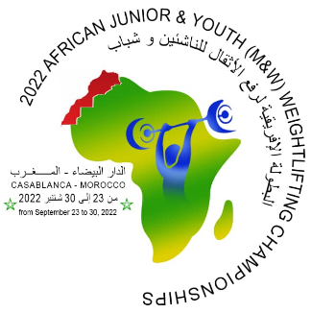
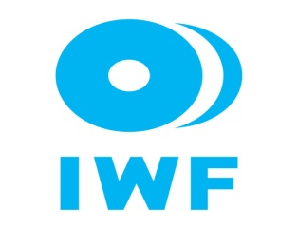
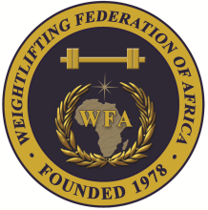

African Junior and Youth Weightlifting Championships
September 23-30, 2022/Casablanca, Morocco

FLIGHT SCHEDULE

Country:

No. | Name | Position | Passport No. | Arrival Details  Date, Time | Airline flight No. | Departure Details  Date Time | Airline flight No.
1
2
3
4
5
6
7
8
9
10
11
12
13
14
15
President /Secretary Sign/stamp…………………………………. Date ……………………….

Should be sent to OC and WFA no later than September 12, 2022

Organising Federation: Continental Federation:
E-mail: frmhmaroc@gmail.com E-mail: manareddin.eshelli@wfa.com.ly

