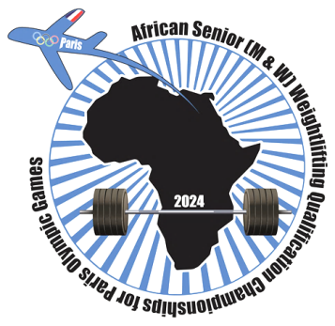

African Senior (34th Men & 23rd Women) Weightlifting Qualification Championships
02-10/02/2024 /Ismailia, Egypt

FLIGHT SCHEDULE FORM

Country:

No. | Name | Position | Passport No. | Arrival Details  Date, Time | Airline flight No. | Departure Details  Date Time | Airline flight No.
1
2
3
4
5
6
7
8
9
10
11
12
13
14
15

President /Secretary Sign/stamp Date:

Should be sent to OC and WFA no later than January 04th, 2024

Organising Federation (EGY): Continental Federation (WFA):
E-mail: weightlifting_egy@yahoo.com E-mail: manareddin.eshelli@wfa.com.ly

