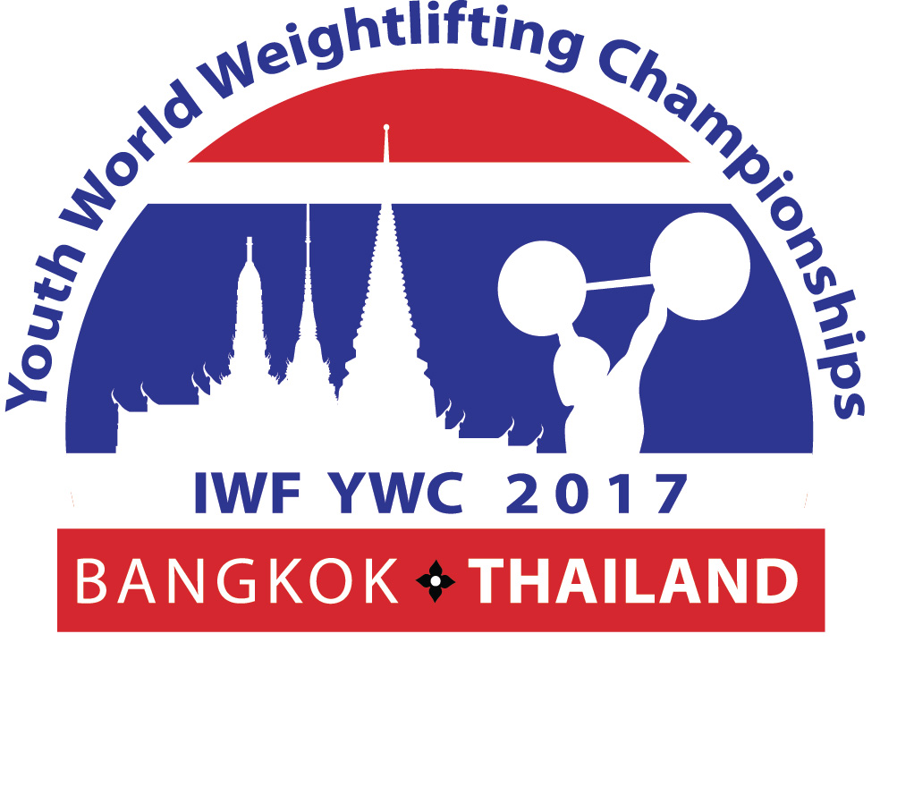
MEDIA ACCREDITATION FORM

Last Name………………………………….…. Name ………………………………………
Nationality…………………………………….. Gender (M / F) …………………………..
AIPS No: ……………………………………….. Date Of Birth …………………………….
Name of the Editorial Office: ……………………………………………………………………………………
………………………………………………………………………………………………………………………………
Phone:…………………………………………… Email: ………………………………………

□ Journalist □ News Agency □ Daily Newspaper
□ Sport Magazine □ Photographer □ Radio Reporter
□ TV Reporter □ Other: …………………………………

Arrival  Date/Time: ………………………………………  Flight Number: ……………………………..  From: …………………………………………… |  | Departure  Date/Time: ………………………………………  Flight Number: ……………………………  To: ……………………………………………

There are 2 options for Media representatives:
□ Pay for Participation Fee with arrangement of accommodation with full board i.e. meals,
local transport and so on from the OC
□ Double room type: US $120 per person per day.
□ Single room type: US $150 per person per day.
□ Pay for Entry Fee (US$ 250 per person) without any arrangement from the OC

This Form must be returned by 4th March 2017 to:

International Weightlifting Federation  Tel.: +3613530530, Fax.: +3613530199  E-mail: lilla.rozgonyi@iwfnet.net  Website: www.iwf.net |  | Thai Amateur Weightlifting Association  Tel.:+66 2170 9461, Fax: +66 2170 9462  e-mail: tawa@tawa.or.th  Website: www.tawa.or.th

