African Weightlifting Championships  22nd Men & 17th Women Junior and 8th Men & 7th Women Youth  Cairo – Egypt (08th to 15th December 2016)  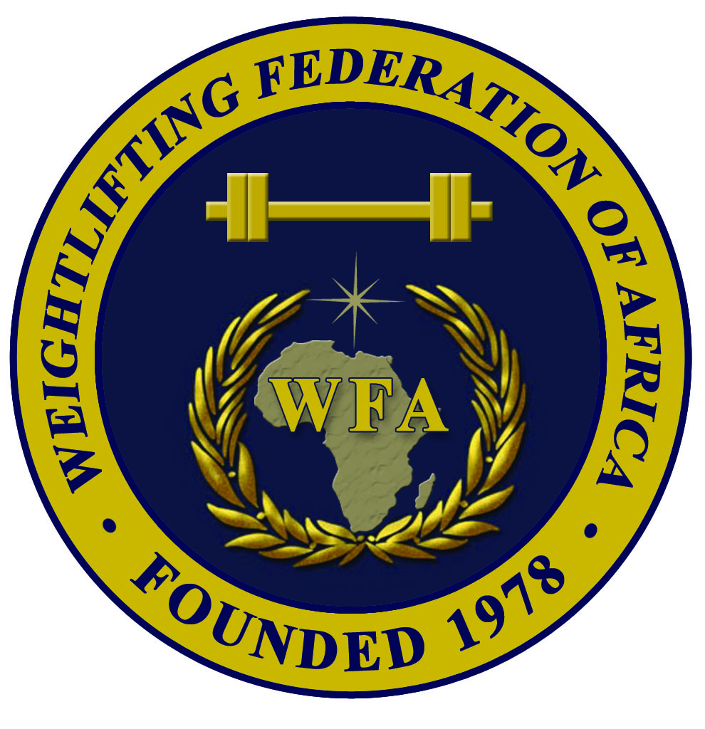 | 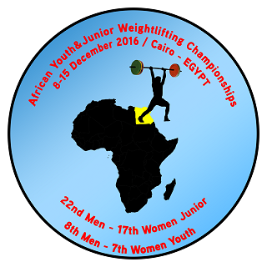  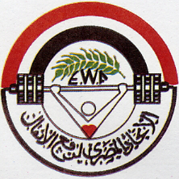 |   

FINAL
Accommodation and Transportation Form

Weightlifting Federation of:

Name |  | Gender | Room Type |  | Arrival |  |  | Departure
Family | Given | M / W | Single | Double | Flight Number | Date | Time | Flight Number | Date | Time

President or General Secretary : Name :……………………………………………………………………..

Date :……………………………………….. Signature :
This Form must be returned by 20th November 2016
WFA : Ain Zarah region - Tripoli, Libya  Tel.Fax: +218 21 7255974  Mobile of WFA Sec. Gen. +218 91 3543635  P.O. Box: 3541 or 4168 – Tripoli  E-mail: newwfa@hotmail.com |  | EGY WF: Cairo – Egypt  Tel.: +202-22621476 – Fax: +202-24031050  Mobile of EGY WF President: +201001769928  Mobile of EGY WF Manager: +201016310631  E-mail: weightlifting_egy@yahoo.com

