African Weightlifting Championships  22nd Men & 17th Women Junior and 8th Men & 7th Women Youth  Cairo – Egypt (08th to 15th December 2016)  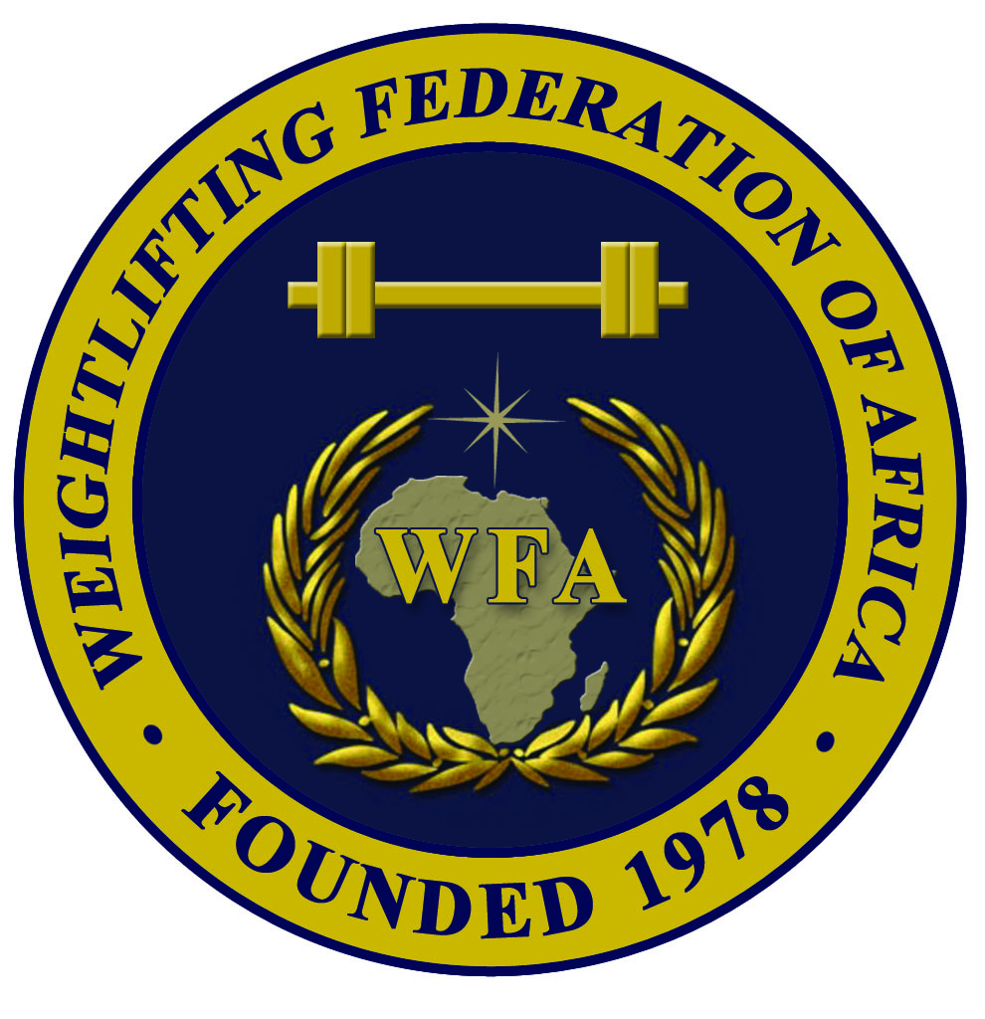 | 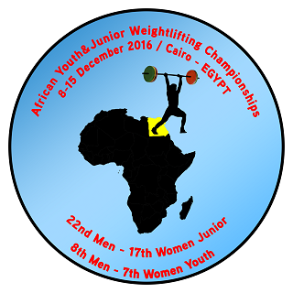  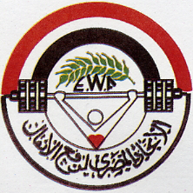 |   

PRELIMINARY ENTRY FORM
JUNIOR MEN

Weightlifting Federation of:

N | Athlete’s name |  |  | Date of birth |  |  | Bodyweight category | Entry Total
N | Family | Given | Middle | Day | Month | Year | Bodyweight category | Entry Total
1
2
3
4
5
6
7
8
R
R

N | Official’s name |  | Date of birth |  |  | Function
N | Family | Given | Day | Month | Year | Function
1 |  |  |  |  |  | Team leader
2 |  |  |  |  |  | Coach
3 |  |  |  |  |  | Doctor
4 |  |  |  |  |  | Therapist
5

President or General Secretary : Name :……………………………………………………………………..

Date :……………………………………….. Signature :

This Form must be returned by 30th October 2016
WFA : Ain Zarah region - Tripoli, Libya  Tel.Fax: +218 21 7255974  Mobile of WFA Sec. Gen. +218 91 3543635  P.O. Box: 3541 or 4168 – Tripoli  E-mail: newwfa@hotmail.com |  | EGY WF: Cairo – Egypt  Tel.: +202-22621476 – Fax: +202-24031050  Mobile of EGY WF President: +201001769928  Mobile of EGY WF Manager: +201016310631  E-mail: weightlifting_egy@yahoo.com

