

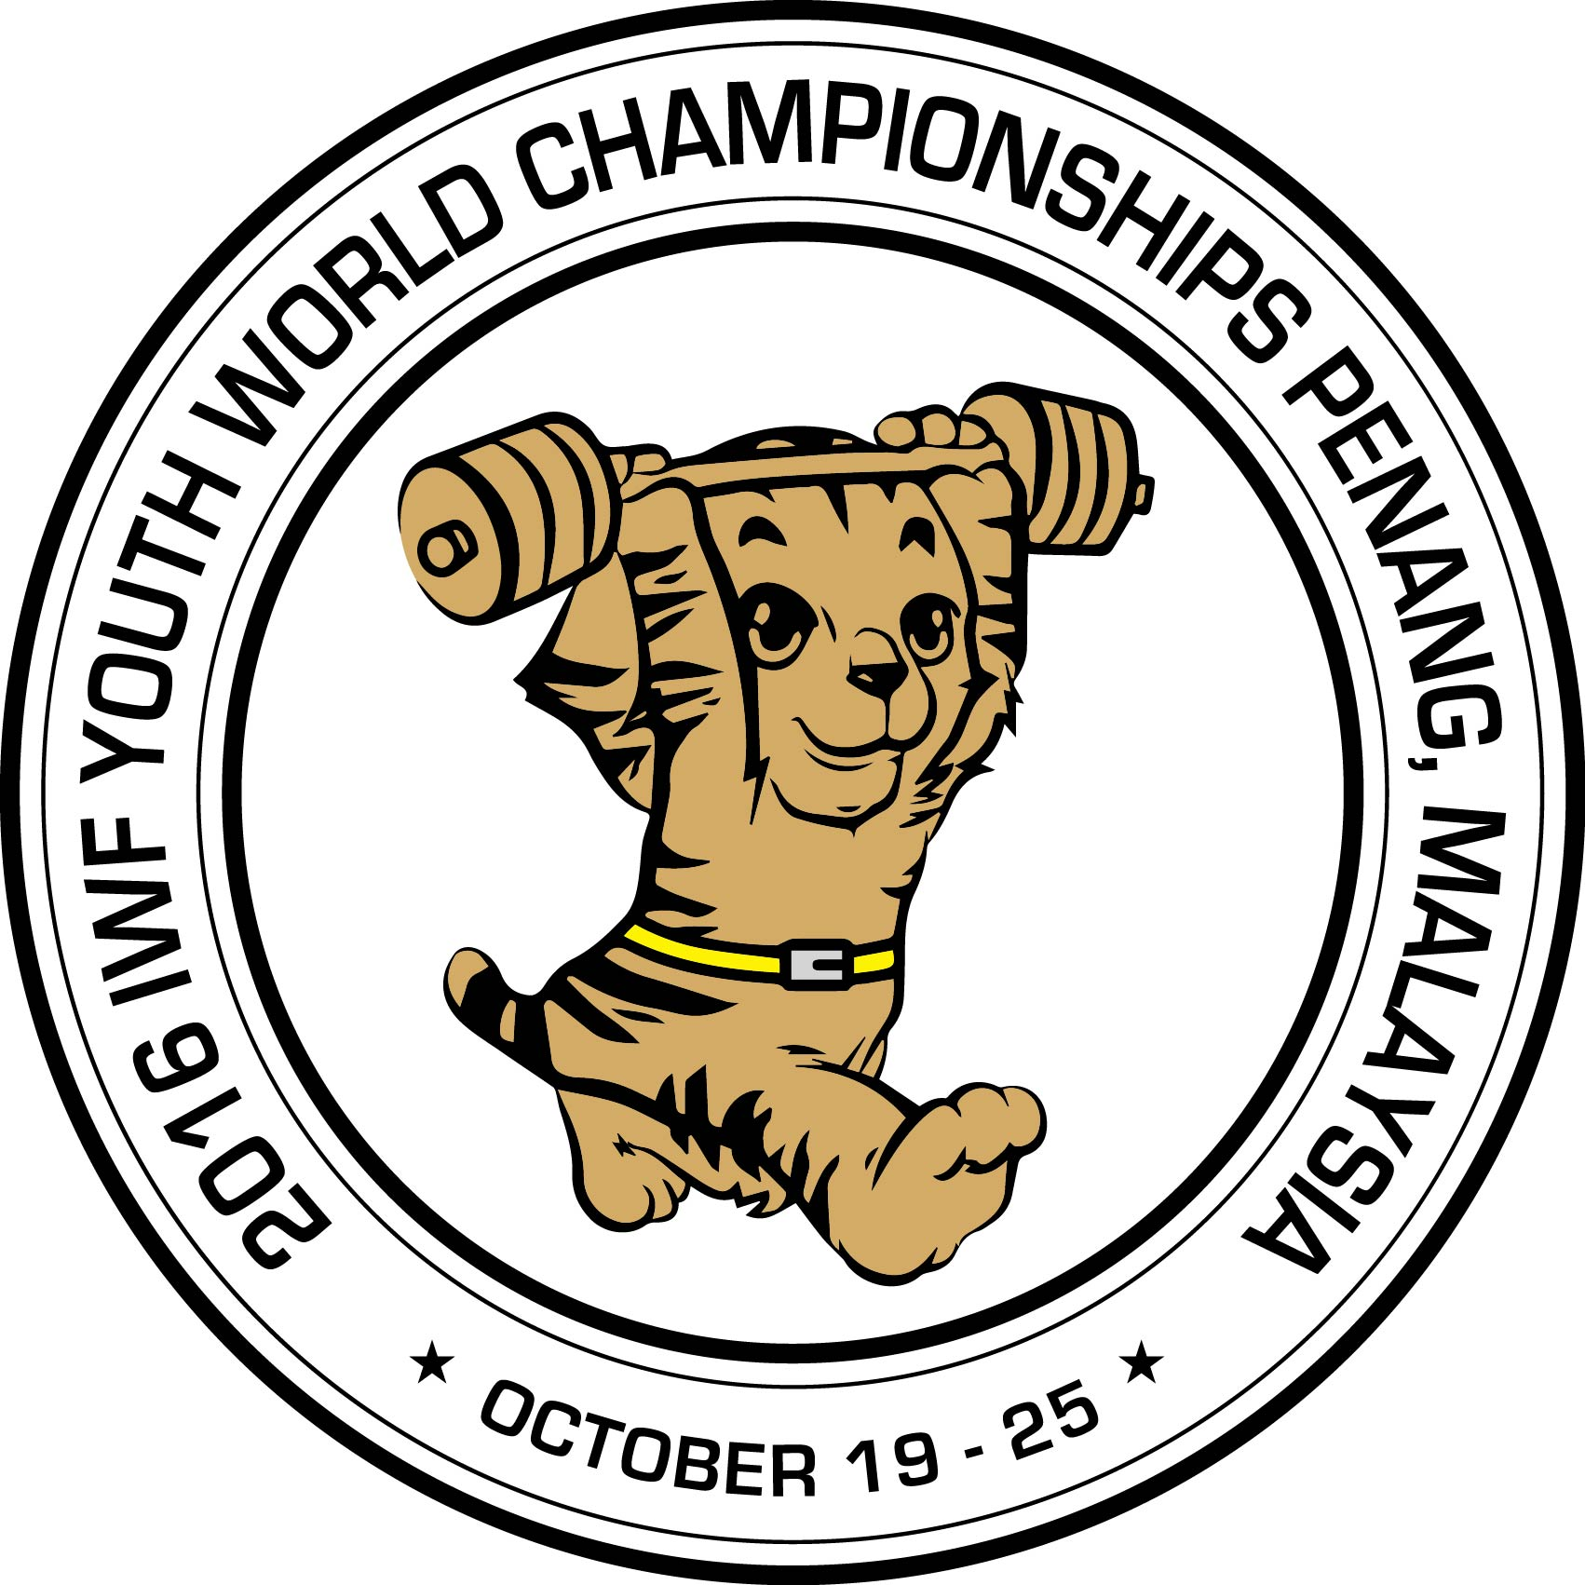

2016 IWF YOUTH WORLD CHAMPIONSHIPS
Penang –Malaysia 19 – 25 October, 2016

MEDIA ACCREDITATION and ACCOMODATION FORM

No. | Surname & Name | COUNTRY | Date of Birth | COMPANY | TYPE of MEDIA | Arrival Date | Departure Date | ROOM Double/Single
1
2
3
4
5
6

Surname and Name:____________________________________ Date: _______________ Signature: _______________________
This form must be returned to the Organising Committee and the IWF by 25 SEPTEMBER 2016 :
Dato Ong Poh Eng Lilla Rozgonyi
President: Organising Committee International Weightlifting Federation
President Malaysia Weightlifting Fed. E-mail: lilla.rozgonyi@iwfnet.net
President International Weightlifting Federation
E-mail: 2016iwfywc@gmail.comTel. +60 12 4001952
Fax: +604 6599082

