

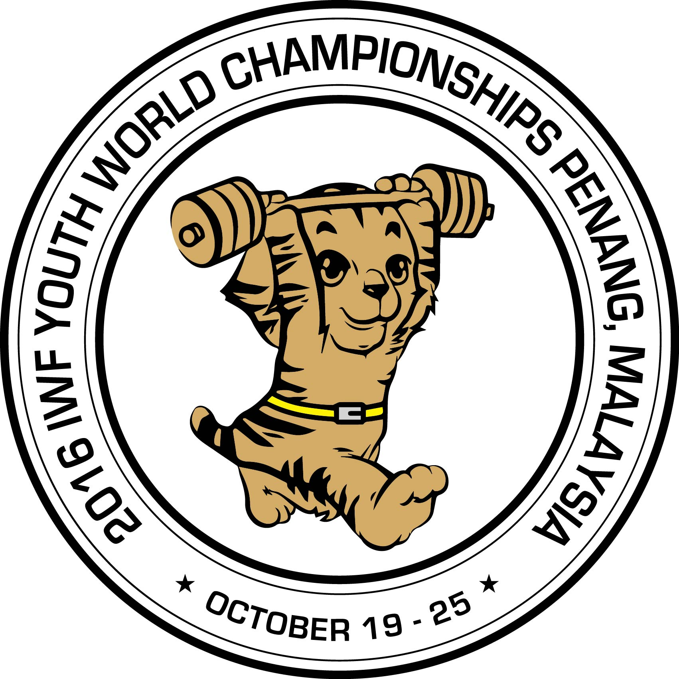

TRANSPORT FORM

2016 IWF YOUTH WORLD CHAMPIONSHIPS
Penang –Malaysia 19 – 25 October, 2016

The………………………….Weightlifting Federation wishes to inform the Organising Committee of their travel arrangements :

COUNTRY | Numbers | Arrival Date | Flight Number | Arrival Time | Departure Date | Flight Number | Departure Time | Numbers

Signature:…………………………………. Date: …………………………………
President or General Secretary
Please email this form no later than September 25, 2016 to:

Dato Ong Poh Eng Paul Coffa MBE
Chairman; Organising Committee Organising Committee
President Malaysia Weightlifting Federation E-mail: owf@bigpond.com
Vice President International Weightlifting Federation
E-mail: 2016iwfywc@gmail.com
Tel. +60 12 4001952 or Fax: +604 6599082

