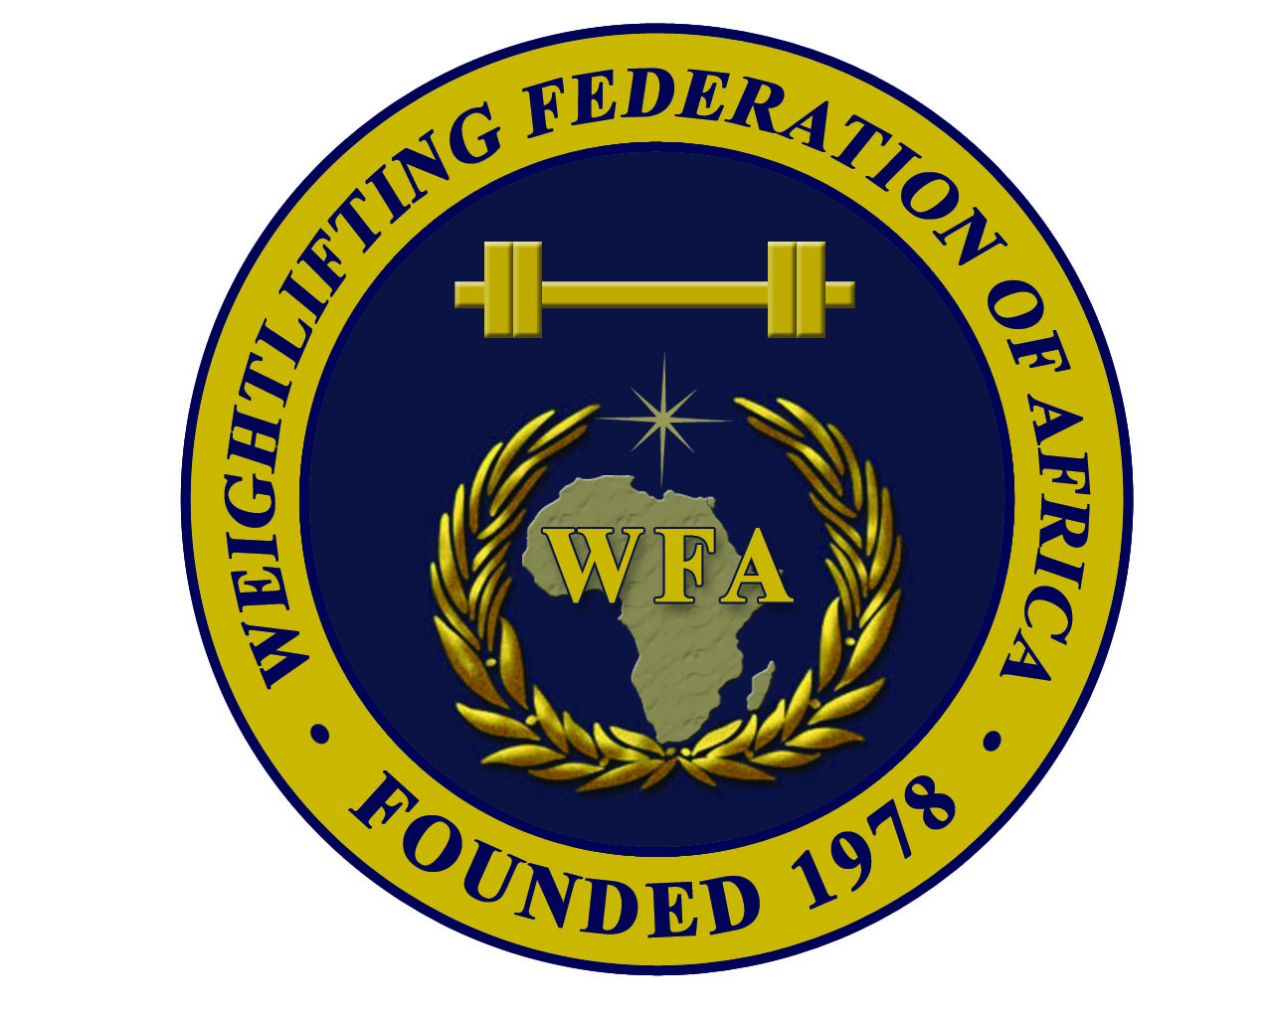  African Senior (26th M & 15th W) Weightlifting Championships Qualification Event for the Games of the XXXI Olympiad in  Rio de Janeiro in 2016 | 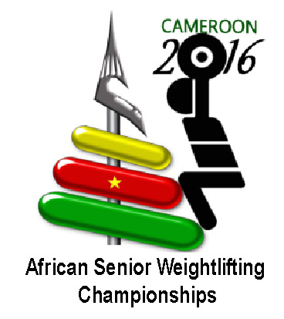 |  | 

FINAL ENTRY FORM
MEN

Weightlifting Federation of:

N | Athlete’s name |  | Date of birth |  |  | Bodyweight category | Entry Total
N | Family | Given | Day | Month | Year | Bodyweight category | Entry Total
1
2
3
4
5
6
7
8
R
R

N | Official’s name |  | Date of birth |  |  | Function
N | Family | Given | Day | Month | Year | Function
1 |  |  |  |  |  | Team leader
2 |  |  |  |  |  | Coach
3 |  |  |  |  |  | Doctor
4 |  |  |  |  |  | Therapist
5

President or General Secretary : Name :……………………………………………………………………..

Date :……………………………………….. Signature :

This Form must be returned by 15th April 2016
WFA : Ain Zarah region - Tripoli - Libya  Tel.Fax: +218 21 7255974  Mobile of WFA Sec. Gen. +218 91 3543635  P.O. Box: 3541 or 4168 – Tripoli  E-mail: newwfa@hotmail.com |  | CWF : Yaoundé – Cameroon  Mobile: +237 699 862 011 or +237 699 207 501  or +237 670 458 248  P.O.Box : 15960 Yaoundé  E-mail: fedehac@yahoo.fr

