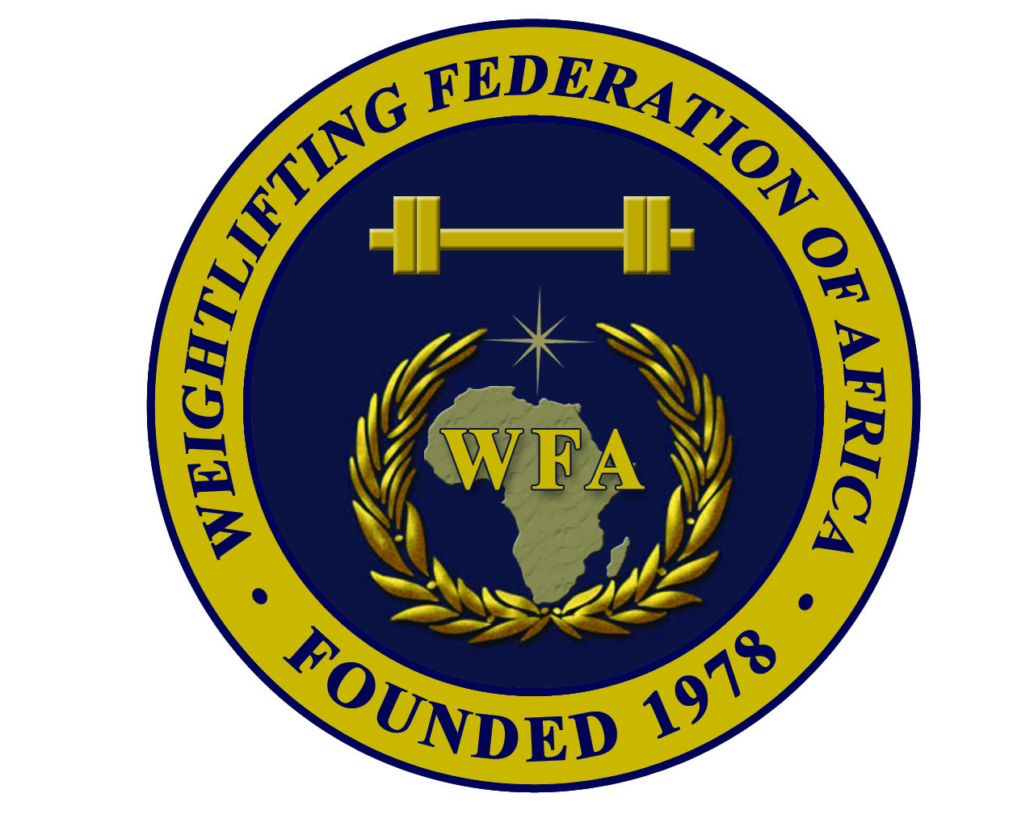  African Senior (26th M & 15th W) Weightlifting Championships Qualification Event for the Games of the XXXI Olympiad in  Rio de Janeiro in 2016 |  |  | 

Preliminary
ACCOMMODATION and TRANSPORTATION FORM

Weightlifting Federation of:

Name |  | Gender | Room Type |  | Arrival |  |  | Departure
Family | Given | M / W | Single | Double | Flight Number | Date | Time |  | Flight Number | Date | Time

President or General Secretary : Name :……………………………………………………………………..

Date :……………………………………….. Signature :
This Form must be returned by 31st March 2016
WFA : Ain Zarah region - Tripoli - Libya  Tel.Fax: +218 21 7255974  Mobile of WFA Sec. Gen. +218 91 3543635  P.O. Box: 3541 or 4168 – Tripoli  E-mail: newwfa@hotmail.com |  | CWF : Yaoundé – Cameroon  Mobile: +237 699 862 011 or +237 699 207 501  or +237 670 458 248  P.O.Box : 15960 Yaoundé  E-mail: fedehac@yahoo.fr

