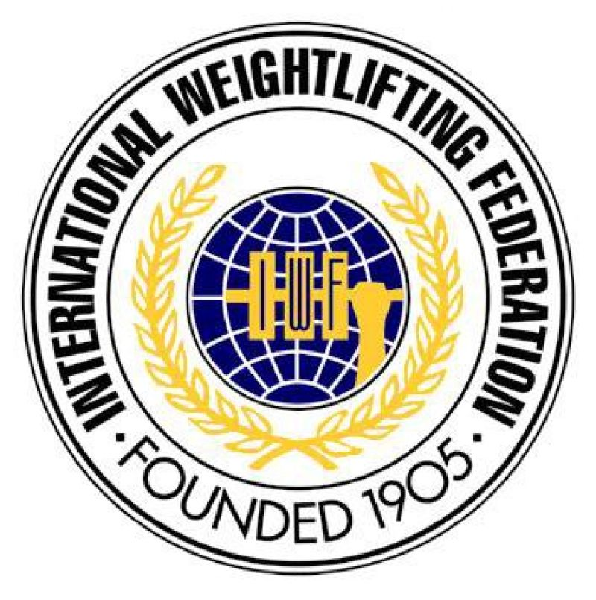
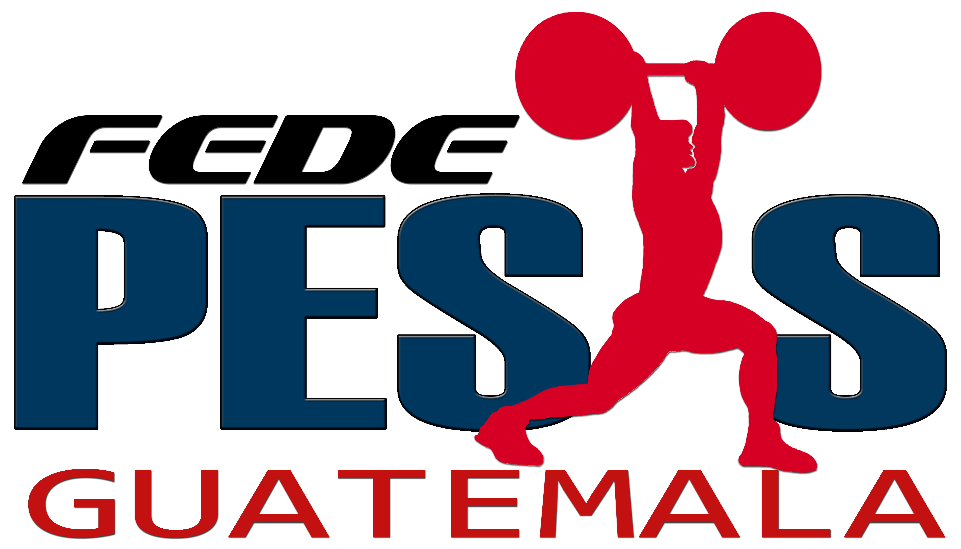
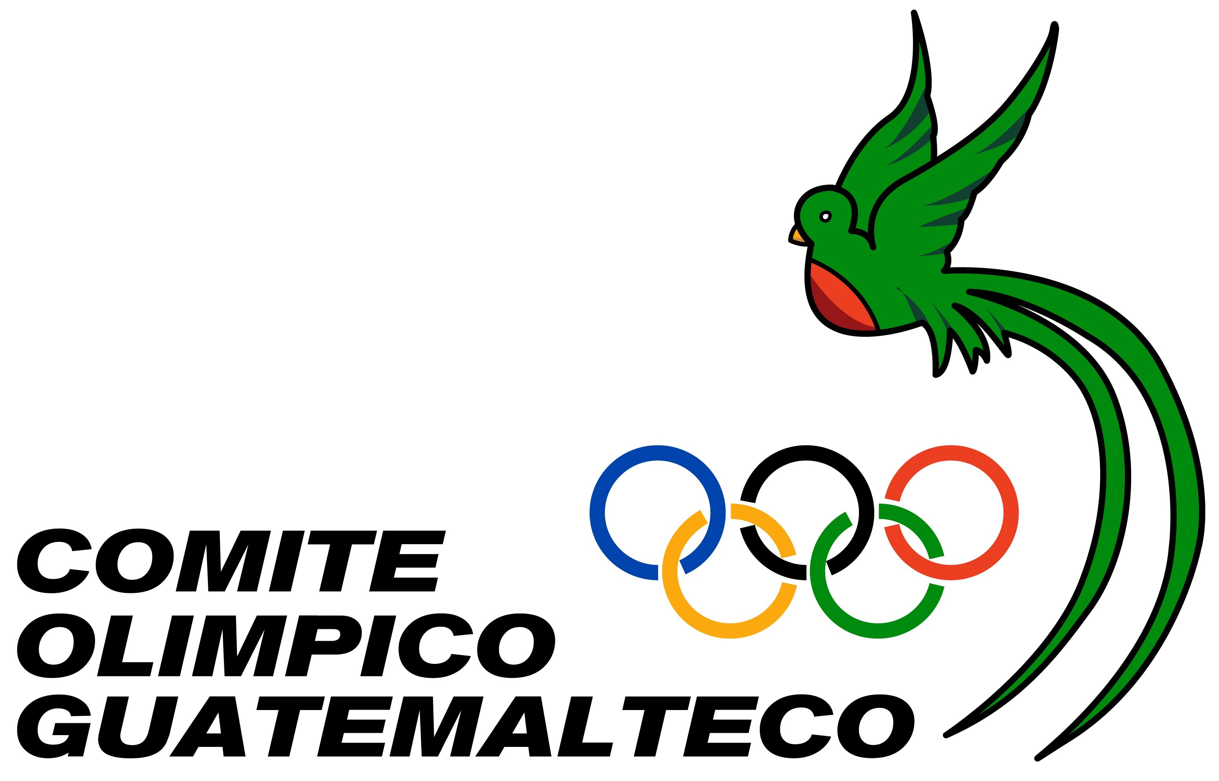
38th MEN – 18th WOMEN WORLD
JUNIOR WEIGHTLIFTING CHAMPIONSHIPS
22 PANAMERICAN CHAMPIONSHIPS
CONTINENTAL QUALIFICATION EVENT
Antigua, Guatemala, May 7th to 18th 2012

ACCOMMODATION FORM

National Federation of:
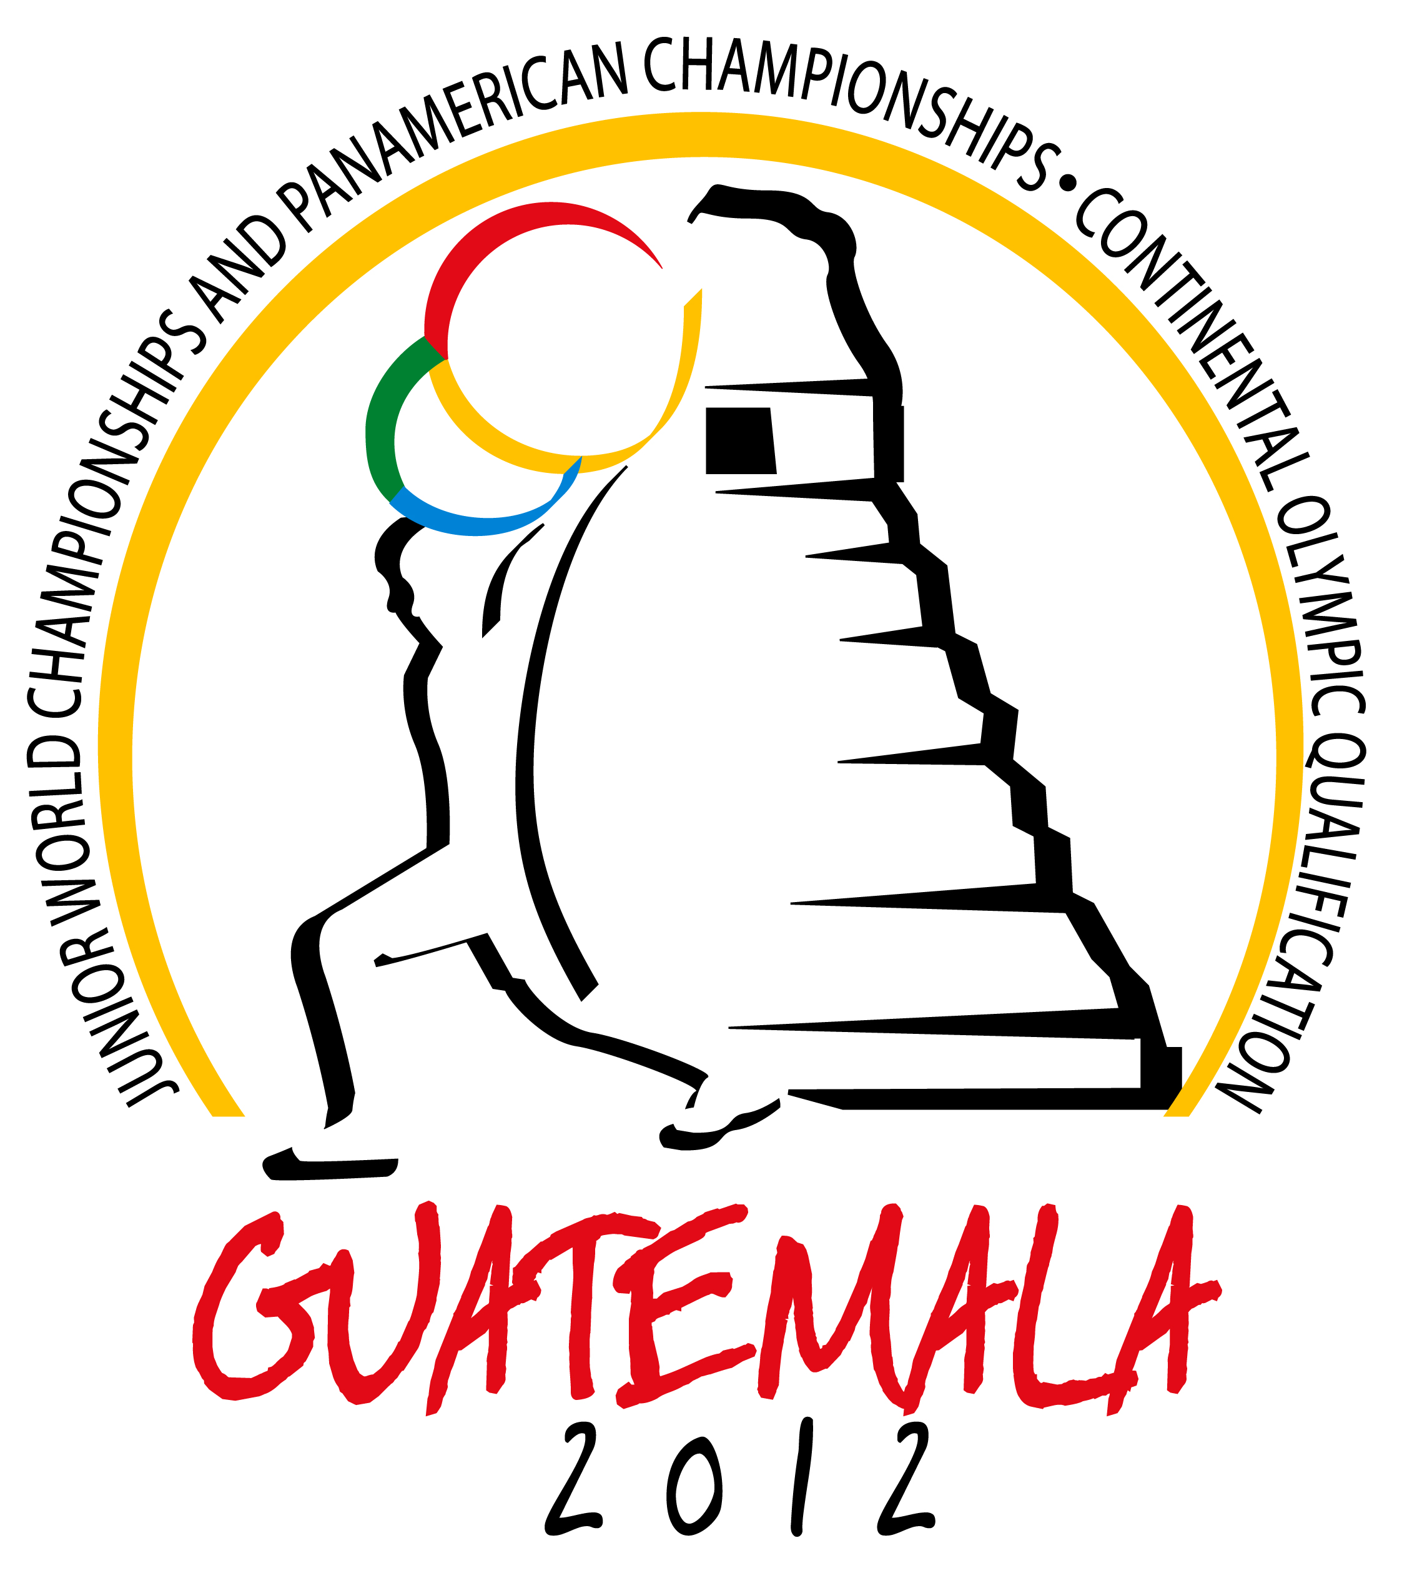
Number of rooms
DATE | SPECIAL PRICE HOTEL |  |  | NOTES
DATE | TRIPLE ROOM | TWIN ROOM | SINGLE ROOM | NOTES
07-May-12
08-May-12
09-May-12
10-May-12
11-May-12
12-May-12
13-May-12
14-May-12
15-May-12
16-May-12
17-May-12
18-May-12
19-May-12
Date
Signature / National Federation
This Form must be returned by April 08st, 2012 to:

Federación Nacional de Levantamiento de Pesas
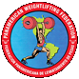
Tel: (+502) 2331-0900 – ( +502 ) 2339-3805
Fax: (+502) 2331-1560
E-mail:fedepesasguate@gmail.com
Website: www.fedepesas.org.gt

