IWF JUNIOR WORLD CHAMPIONSHIPS AND PAN AMERICAN OLYMPIC QUALIFICATION EVENT
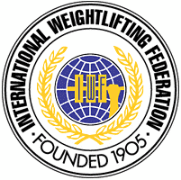

Antigua Guatemala, May 8th to 18th 2012

PRELIMINARY ENTRY FORM
WOMEN

Weightlifting Federation of…................................

 | Athlete’s name |  | Date of Birth |  |  | Entry Total | Bodyweight category
 | Family | Give | Day | Month | Year | Entry Total | Olympic Qual. Event | Continental Ch. | Junior World Ch.
1
2
3
4
5
6
7
8R
9R

 | Official’s Names |  | Date of Birth |  |  | Function
 | FAMILY | Given | Day | Month | Year | Function
1
2
3
4
5

President or General Secretary
Name:_______________________________Date:____________________________ Signature: _____________________________________________________________

This Form must be returned by Mach 8, 2012 to:

Federación Nacional de Levantamiento de Pesas | International Weightlifting Federation
Tel: ( +502 ) 2331-0900 – ( +502 ) 2339-3805 | 1146 Budapest, Istvanmezei ut l-3. HUNGARY
Fax: ( +502 ) 2331-1560 | Fax: +36 1 353 0199, +36 1 269 0208
E-mail :fedepesasguate@gmail.com | E-mail: eva.moska@iwfnet.net
Website: www.fedepesas.org.gt
Address: Organizing Committee - 2012: Fedepesas Guatemala
Antigua - Guatemala

