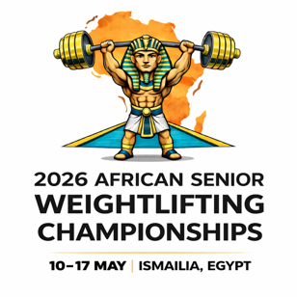




African Senior (36th Men & 25th Women) Weightlifting Championships
10-17/05/2026 /Ismailia, Egypt

PRELIMINARY WOMEN SENIOR ENTRY FORM

National Federation of:
No. | Athlete's name |  | Date of birth |  |  | Bodyweight Category | Entry Total
No. | Given | Family | DD | MM | YYYY | Bodyweight Category | Entry Total
1
2
3
4
5
6
7
8
9
10
11
12
13
14
15
16
No. | Official’s name |  | Date of birth |  |  | Function
No. | Given | Family | DD | MM | YYYY | Function
1
2
3
4
5

President or General Secretary name:

Date: Signature: Stamp:

Should be sent to LOC and WFA no later than March 12th, 2026

Organising Federation (EGY): Continental Federation (WFA):
E-mail: weightlifting_egy@yahoo.com E-mail: manareddin.eshelli@wfa.com.ly

