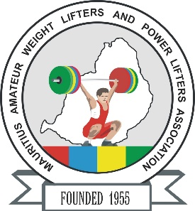
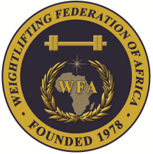


African Senior (35th Men & 24th Women) Weightlifting Championships
20-28/04/2025 /Moka, Mauritius

TEAM ACCOMMODATION FORM

Country:

Date | Single rooms | Twin rooms | Triple rooms
April 19, 2025
April 20, 2025
April 21, 2025
April 22, 2025
April 23, 2025
April 24, 2025
April 25, 2025
April 26, 2025
April 27, 2025
April 28, 2025

President or General Secretary

Name: Date: Signature:

Should be sent to OC and WFA respectively no later than March 23rd, 2025

Organising Federation (MRI): Continental Federation (WFA):
E-mail: mauritius.weightlifting@hotmail.com E-mail: manareddin.eshelli@wfa.com.ly

