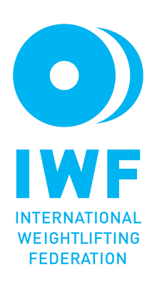

IWF
Development Program
2024

Application Form

Deadline to return: 15th March 2024

Name of the Federation: …………………………………………

Contact details of the Federation:

- E-mail:
- Telephone

- Website

- Contact person

1. Equipment □

Detailed description:

Would you like to deduct the freight charge from the funds?
□ yes
□ no

2. Seminar □

Detailed description (topics covered):

Details of the seminar:

Location
Level
Start date
End date
Number of participants
Proposed expert

Purposes of the seminar:

Detailed program:

3. Event support □

The Federation shall indicate to the IWF 4 weeks before the Event, the athletes’ names and the event where they want to use the funds.

4. IWF Membership fee deduction □

5. CF Membership fee deduction □

6. Technical Officials items □
The list shall be sent with the application.

Budgetary information:

Total budget of the project, indication of the other resources (apart from the funds requested from the IWF):

Total budget of the project: …………………………………

Other resources:

Banking details (name and address of the beneficiary and the bank, IBAN number, Swift code)

Full name:
Full address:
(Street, Postcode, City, Country)
Bank name:
Bank address:
IBAN or Bank Account No:
SWIFT / BIC Code:

****************************************************************************************

Other information

Any support received from the IWF in the previous 4 years:

_________________________________________
Name and Signature
President / General Secretary

__________________________________________
National Federation’s Official Seal / Stamp

