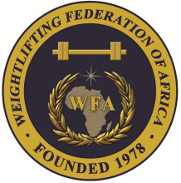
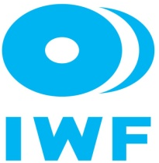

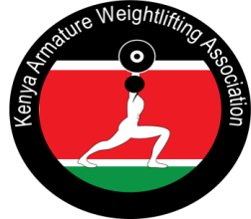

African Youth and Junior Weightlifting Championships
Dec 5-11 2020/Nairobi, Kenya

FINAL WOMEN YOUTH ENTRY FORM

Country:
No. | Athlete's name |  | Date of birth |  |  | Bodyweight Category | Entry Total
No. | FAMILY | Given | DD | MM | YYYY | Bodyweight Category | Entry Total
1
2
3
4
5
6
7
8
9
10
11R
12R

No. | Official’s name |  | Date of birth |  |  | Function
No. | FAMILY | Given | DD | MM | YYYY
1
2
3
4
5

President or General Secretary

Name:_____________________________ Date:_____________ Signature: _____________

Should be sent to OC and WFA no later than November 05, 2020

Organising Federation: Continental Federation:
E-mail: weightliftingkenya@yahoo.com E-mail: manareddin.eshelli@wfa.com.ly

