

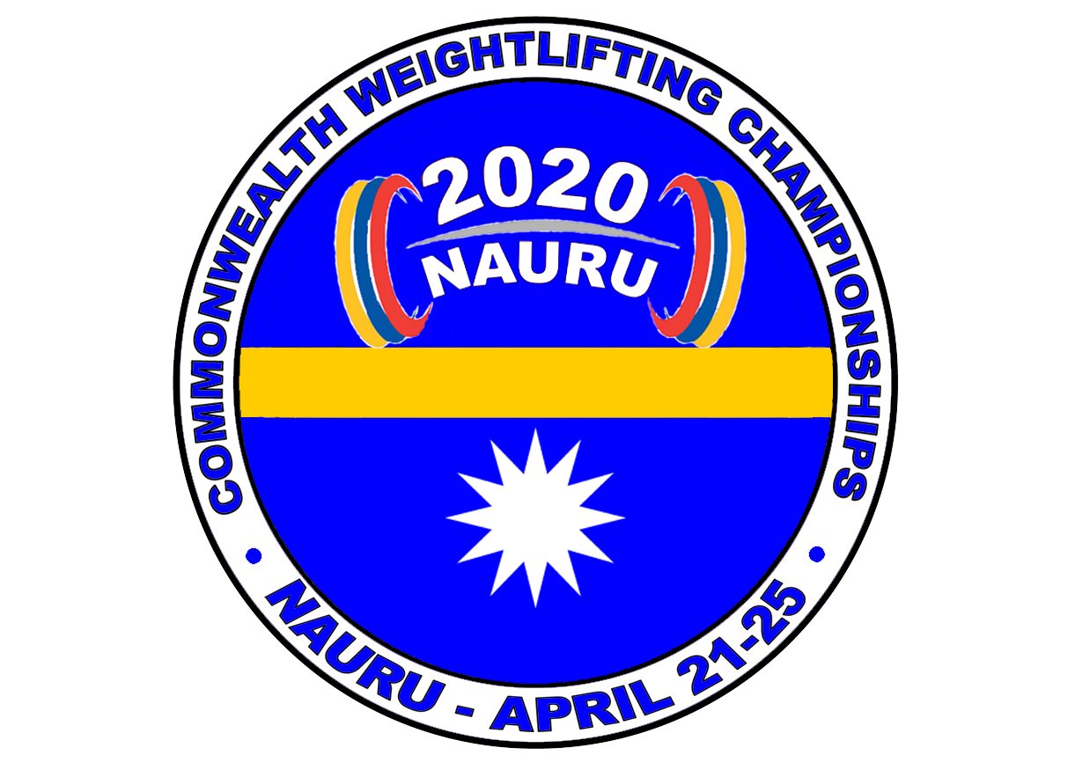
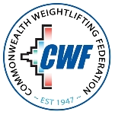

ACCOMMODATION FORM

2020 COMMONWEALTH WEIGHTLIFTING CHAMPIONSHIPS
NAURU- APRIL 21-25
SILVER EVENT FOR 2020 OLYMPIC QUALIFICATION

The Weightlifting Federation wishes to inform the Organising Committee of their accommodation requirements :

Per person: AUD $150.00 AUD $130.00 AUD $120.00
USD$ 105.00 USD$ 92.00 USD$ 85.00
DATE | SINGLE ROOM | TWIN ROOM | TRIPLE ROOM
18 April 2020
19 April 2020
20 April 2020
21 April 2020
22 April 2020
23 April 2020
24 April 2020
25 April 2020
26 April 2020
Please email this accommodation form not later then February 20th to:
Paul Coffa Copies to: Trent Dabwido
OWF General Secretary Organising Committee
E-mail: owf@bigpond.com E-mail tdabwido@gmail.com Tel : +61 417611730
Tel: +687 467640 or +687 948756
Mobile: +61 457778900

Country: __________ Signature:________________ Date: ___________

