
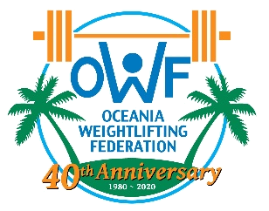

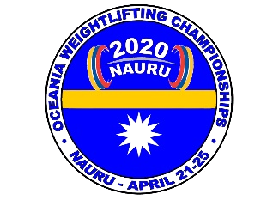

TRANSPORT FORM

2020 OCEANIA WEIGHTLIFTING CHAMPIONSHIPS
NAURU- APRIL 21-25
GOLD EVENT FOR 2020 OLYMPIC QUALIFICATION

The Weightlifting Federation wishes to inform the Organising Committee of their accommodation requirements :

COUNTRY | Number  of persons | Arrival Date | Flight Number | Arrival Time | Departure Date | Flight Number | Departure Time

Country: ______ Signature:___ _____________ Date: ___________

Please email this transport form not later then February 20th to:
Paul Coffa Copies to: Trent Dabwido
OWF General Secretary Organising Committee
E-mail: owf@bigpond.com E-mail tdabwido@gmail.com Tel : +61 417611730
Tel: +687 467640 or +687 948756
Mobile: +61 457778900

