
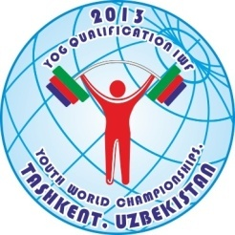

2013 IWF YOUTH WORLD CHAMPIONSHIPS
(YOG QUALIFICATION) TASHKENT, UZBEKISTAN
PRELIMINARY ENTRY FORM FOR GIRLS

Weightlifting Federation of: _______________________________________

N | Athlete’s name |  | Date of birth |  |  | Bodyweight category | Entry Total
N | Family | Given | Day | Month | Year | Bodyweight category | Entry Total
1
2
3
4
5
6
7
8R
9R

N | Official’s name |  | Date of Birth |  |  | Function
N | Family | Given | Day | Month | Year | Function
1
2
3
4
5

President or General Secretary
Name _________________________________ Signature_________________________
Date_________________________________

This Form must be returned by 07th February 2013

to

International Weightlifting Federation Uzbekistan Weightlifting Federation
Istvanmezei ut 1-3. Furkat Street #1, Index: 100027
1146 Budapest – HUNGARY Tashkent, Uzbekistan
Tel.: +3613530530, Fax: +3613530199 Tel.: +998 71 2455590
e-mail: attila.adamfi@iwfnet.net Email: uzbek_weightlifting@yahoo.com
web site: http://www.iwf.net

