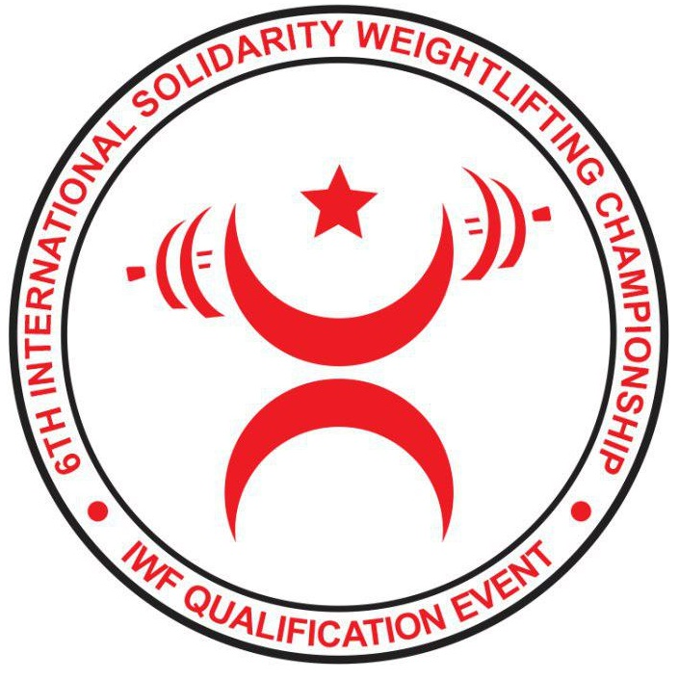
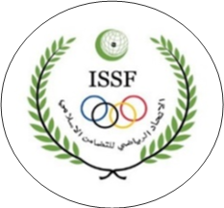




ACCOMMODATION FORM
WEIGHTLIFTING FEDERATION OF | ……………………………………………………………………………

Number of rooms
DATE | SINGLE ROOM | DOUBLE ROOM
07.02.2020
08.02.2020
09.02.2020
10.02.2020
11.02.2020
12.02.2020
13.02.2020
14.02.2020
15.02.2020
16.02.2020

President or General Secretary: Name: ……………………………………………………………………..
Date: ……………………………………….. Signature:
This Form must be returned by 8th January 2020
ISSF  Pince Faisal Bin Fahad Olympic Complex  Al Diwan St, Al Hada, Riyadh 12921  Tel : 00966 112810 895  00966 114808986  Fax : 00966 114822145  E.mail : info@issf.sa |  | UzWF  Tashkent city, Olmazor district 15/1, Uzbekistan  100003. Tel/fax: +998712455590  uzbek_weightlifting@yahoo.com

