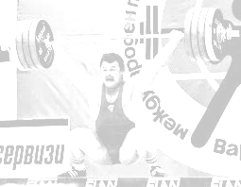
ALEXANDER CUP
International cup in memory of the Two-time Olympic Champion Alexander Kurlovich
will be the Tokyo 2020 Qualification Event Silver Event
1 - 4 November 2019, Grodno, Republic of Belarus
_______________________________________________________________________________________________________________________________________________________

PRELIMINARY ENTRY FORM
MEN

The Preliminary Entry Form must be submitted to the Organizing Committee prior to 1 September 2019
BELARUSIAN WEIGHTLIFTING UNION (BWU)
Republic of Belarus, Minsk city, ul. Y. Mavra, 41-510, 220015
Tel: (+ 375-17) 299-08-02, 255-89-55, Fax: (+ 375-17) 299-08-02
e-mail: bwf2004@rambler.ru, belwu@rambler.ru

№ | Bodyweight  Category |  | Names of Athletes | Date of Birth | Entry  Total | Arrival date | Arrival time  Flight No. | Departure date |  | Departure time Flight No. | Passport No. | Visa No.
1
2
3
4
5
6
7
8
9
10
11R
12R
№ |  | Name of Officials |  | Date of Birth | Position | Arrival date | Arrival time  Flight No. | Departure date | Departure time Flight No. |  | Passport No. | Visa No.
1 |  |  |  |  | Team leader
2 |  |  |  |  | Doctor
3 |  |  |  |  | Coach
4 |  |  |  |  | Therapist
5
6
7

Country: ____________________ Signature: ____________________ Date: ____________________
ALEXANDER CUP
International cup in memory of the Two-time Olympic Champion Alexander Kurlovich
will be the Tokyo 2020 Qualification Event Silver Event
1 - 4 November 2019, Grodno, Republic of Belarus
_______________________________________________________________________________________________________________________________________________________

PRELIMINARY ENTRY FORM
WOMEN

The Preliminary Entry Form must be submitted to the Organizing Committee prior to 1 September 2019
BELARUSIAN WEIGHTLIFTING UNION (BWU)
Republic of Belarus, Minsk city, ul. Y. Mavra, 41-510, 220015
Tel: (+ 375-17) 299-08-02, 255-89-55, Fax: (+ 375-17) 299-08-02
e-mail: bwf2004@rambler.ru, belwu@rambler.ru

№ | Bodyweight  Category |  | Names of Athletes | Date of Birth | Entry  Total | Arrival date | Arrival time  Flight No. | Departure date |  | Departure time Flight No. | Passport No. | Visa No.
1
2
3
4
5
6
7
8
9
10
11R
12R
№ |  | Name of Officials |  | Date of Birth | Position | Arrival date | Arrival time  Flight No. | Departure date | Departure time Flight No. |  | Passport No. | Visa No.
1 |  |  |  |  | Team leader
2 |  |  |  |  | Doctor
3 |  |  |  |  | Coach
4 |  |  |  |  | Therapist
5
6
7

Country: ____________________ Signature: ____________________ Date: ____________________
ALEXANDER CUP
International cup in memory of the Two-time Olympic Champion Alexander Kurlovich
will be the Tokyo 2020 Qualification Event Silver Event
1 - 4 November 2019, Grodno, Republic of Belarus
_______________________________________________________________________________________________________________________________________________________

FINAL ENTRY FORM
MEN

The Final Entry Form must be submitted to the Organizing Committee prior to 1 October 2019
BELARUSIAN WEIGHTLIFTING UNION (BWU)
Republic of Belarus, Minsk city, ul. Y. Mavra, 41-510, 220015
Tel: (+ 375-17) 299-08-02, 255-89-55, Fax: (+ 375-17) 299-08-02
e-mail: bwf2004@rambler.ru, belwu@rambler.ru

№ | Bodyweight  Category |  | Names of Athletes | Date of Birth | Entry  Total | Arrival date | Arrival time  Flight No. | Departure date |  | Departure time Flight No. | Passport No. | Visa No.
1
2
3
4
5
6
7
8
9
10
11R
12R
№ |  | Name of Officials |  | Date of Birth | Position | Arrival date | Arrival time  Flight No. | Departure date | Departure time Flight No. |  | Passport No. | Visa No.
1 |  |  |  |  | Team leader
2 |  |  |  |  | Doctor
3 |  |  |  |  | Coach
4 |  |  |  |  | Therapist
5
6
7

Country: ____________________ Signature: ____________________ Date: ____________________
ALEXANDER CUP
International cup in memory of the Two-time Olympic Champion Alexander Kurlovich
will be the Tokyo 2020 Qualification Event Silver Event
1 - 4 November 2019, Grodno, Republic of Belarus
_______________________________________________________________________________________________________________________________________________________

FINAL ENTRY FORM
WOMEN

The Final Entry Form must be submitted to the Organizing Committee prior to 1 October 2019
BELARUSIAN WEIGHTLIFTING UNION (BWU)
Republic of Belarus, Minsk city, ul. Y. Mavra, 41-510, 220015
Tel: (+ 375-17) 299-08-02, 255-89-55, Fax: (+ 375-17) 299-08-02
e-mail: bwf2004@rambler.ru, belwu@rambler.ru

№ | Bodyweight  Category |  | Names of Athletes | Date of Birth | Entry  Total | Arrival date | Arrival time  Flight No. | Departure date |  | Departure time Flight No. | Passport No. | Visa No.
1
2
3
4
5
6
7
8
9
10
11R
12R
№ |  | Name of Officials |  | Date of Birth | Position | Arrival date | Arrival time  Flight No. | Departure date | Departure time Flight No. |  | Passport No. | Visa No.
1 |  |  |  |  | Team leader
2 |  |  |  |  | Doctor
3 |  |  |  |  | Coach
4 |  |  |  |  | Therapist
5
6
7

Country: ____________________ Signature: ____________________ Date: ____________________
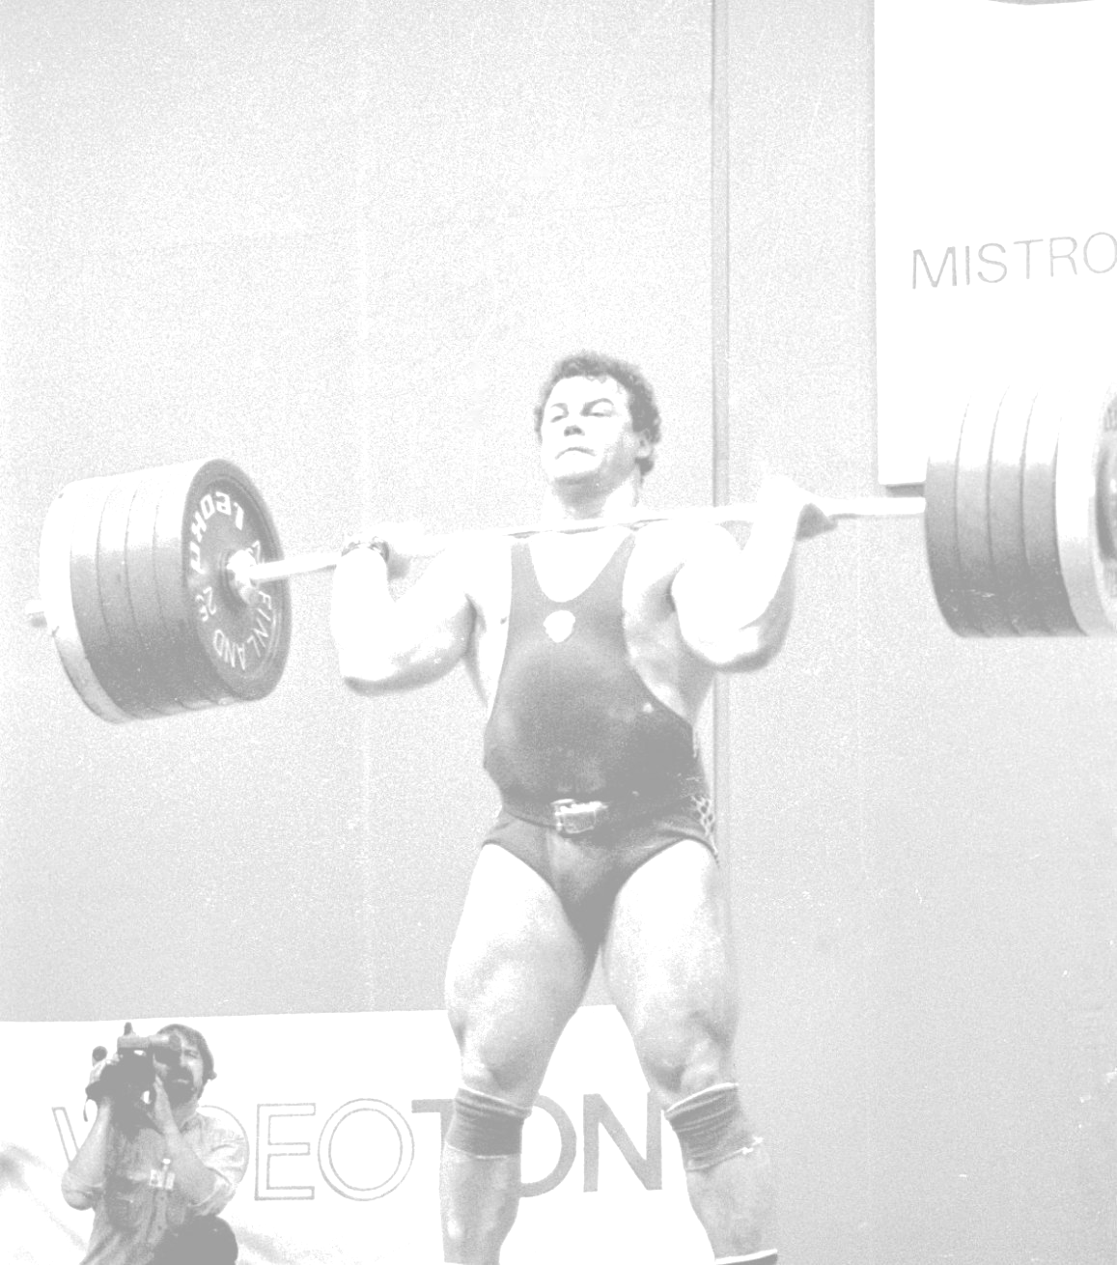
ALEXANDER CUP
International cup in memory
of the Two-time Olympic Champion Alexander Kurlovich
will be the Tokyo 2020 Qualification Event Silver Event
1 - 4 November 2019, Grodno, Republic of Belarus
_________________________________________________________________________________________________________

TEAM ACCOMMODATION FORM

The Accommodation Form must be submitted to the Organizing Committee prior to 15 October 2019
BELARUSIAN WEIGHTLIFTING UNION (BWU)
Republic of Belarus, Minsk city, ul. Y. Mavra, 41-510, 220015
Tel: (+ 375-17) 299-08-02, 255-89-55, Fax: (+ 375-17) 299-08-02
e-mail: bwf2004@rambler.ru, belwu@rambler.ru

Date | Single Room | Double Room
1 NOV 2019
2 NOV 2019
3 NOV 2019
4 NOV 2019
5 NOV 2019

Country: _______________ Signature: _______________ Date: _______________

ALEXANDER CUP
International cup in memory
of the Two-time Olympic Champion Alexander Kurlovich
will be the Tokyo 2020 Qualification Event Silver Event
1 - 4 November 2019, Grodno, Republic of Belarus
_________________________________________________________________________________________________________

TRANSPORTATION FORM

The Transportation Form must be submitted to the Organizing Committee prior to 15 October 2019
BELARUSIAN WEIGHTLIFTING UNION (BWU)
Republic of Belarus, Minsk city, ul. Y. Mavra, 41-510, 220015
Tel: (+ 375-17) 299-08-02, 255-89-55, Fax: (+ 375-17) 299-08-02
e-mail: bwf2004@rambler.ru, belwu@rambler.ru

Arrival in Minsk
Date:
Time:
Flight:
(Airline code and Flight number)
Number of delegation members

Departure from Minsk
Date:
Time:
Flight:
(Airline code and Flight number)
Number of delegation members

Country: _______________ Signature: _______________ Date: _______________

