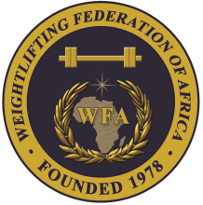
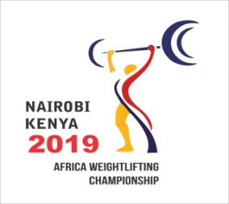

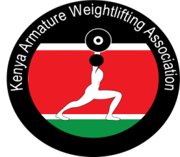

Zone Two Senior Africa Olympic Weightlifting Qualification Championship
July 6-12, 2019 / Nairobi, Kenya

WOMEN FINAL ENTRY FORM
Country:
No. | Athlete's name |  | Date of birth |  |  | Entry Total | Bodyweight Category
No. | FAMILY | Given | DD | MM | YYYY | Entry Total | Bodyweight Category
1
2
3
4
5
6
7
8
9
10
11R
12R

No. | Official’s name |  | Date of birth |  |  | Function
No. | FAMILY | Given | DD | MM | YYYY | Function
1
2
3
4
5

President or General Secretary

Name:_____________________________ Date:______________________ Signature: ____________________

Should be sent to OC and WFA no later than June 06, 2019
Organising Federation: Continental Federation:
E-mail: weightliftingkenya@yahoo.com E-mail: newwfa@hotmail.com

