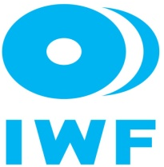
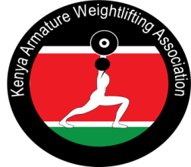

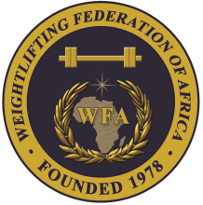
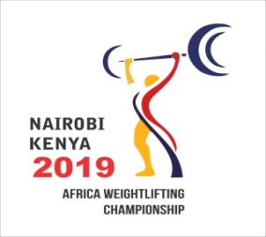

Zone Two Senior Africa Olympic Weightlifting Qualification Championship
July 6-12, 2019 / Nairobi, Kenya

TEAM ACCOMMODATION FORM

Date | Single Room | Double Room | Triple
July 6, 2019
July 7, 2019
July 8, 2019
July 9, 2019
July 10, 2019
July 11, 2019
.

President or General Secretary

Name:_____________________________ Date:_______________ Signature: __________________

Should be sent to OC and WFA no later than June 20, 2019
Organising Federation: Continental Federation:
E-mail: weightliftingkenya@yahoo.com E-mail: newwfa@hotmail.com

