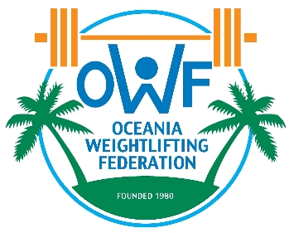

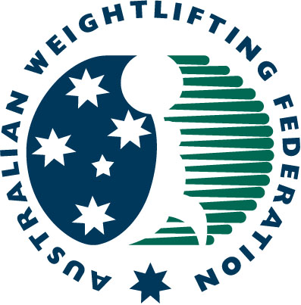
2017 Commonwealth & Oceania Championships

(Senior, Junior & Youth)
03 – 09 September 2017
Gold Coast, Australia
FINAL ENTRY FORM

Weightlifting Federation of

SENIOR MEN
 | ATHLETE'S NAME |  | DATE OF BIRTH |  |  | Bodyweight Category | Entry Total
 | Family Name | First Name | Day | Month | Year | Bodyweight Category | Entry Total
1
2
3
4
5
6
7
8
RES
RES

SENIOR WOMEN
 | ATHLETE'S NAME |  | DATE OF BIRTH |  |  | Bodyweight Category | Entry Total
 | Family Name | First Name | Day | Month | Year | Bodyweight Category | Entry Total
1
2
3
4
5
6
7
8
RES
RES

JUNIOR MEN
 | ATHLETE'S NAME |  | DATE OF BIRTH |  |  | Bodyweight Category | Entry Total
 | Family Name | First Name | Day | Month | Year | Bodyweight Category | Entry Total
1
2
3
4
5
6
7
8
RES
RES

JUNIOR WOMEN
 | ATHLETE'S NAME |  | DATE OF BIRTH |  |  | Bodyweight Category | Entry Total
 | Family Name | First Name | Day | Month | Year | Bodyweight Category | Entry Total
1
2
3
4
5
6
7
8
RES
RES

YOUTH MEN
 | ATHLETE'S NAME |  | DATE OF BIRTH |  |  | Bodyweight Category | Entry Total
 | Family Name | First Name | Day | Month | Year | Bodyweight Category | Entry Total
1
2
3
4
5
6
7
8
RES
RES

YOUTH WOMEN
 | ATHLETE'S NAME |  | DATE OF BIRTH |  |  | Bodyweight Category | Entry Total
 | Family Name | First Name | Day | Month | Year | Bodyweight Category | Entry Total
1
2
3
4
5
6
7
8
RES
RES

TEAM OFFICIALS
TEAM OFFICIAL'S NAME |  | DATE OF BIRTH |  |  | POSITION
Family Name | First Name | Day | Month | Year | POSITION

President or General Secretary

Name: Date: Signature:

These Forms must be returned by 21st July 2017 to:

Paul Coffa  Secretary General  Commonwealth Weightlifting Federation  Oceania Weightlifting Federation  E-mail: owf@bigpond.com or owf@mls.nc |  | Mike Keelan  CEO  Australian Weightlifting Federation  E-mail: mkeelan@awf.com.au

