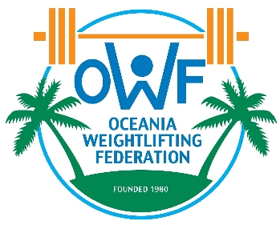
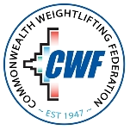

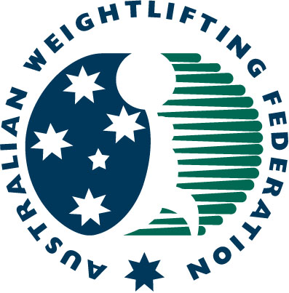
2017 COMMONWEALTH & OCEANIA WEIGHTLIFTING CHAMPIONSHIPS
(Senior-Junior-Youth) September 03-09
FINAL ACCOMMODATION and TRANSPORTATION FORM

Weightlifting Federation name:

Name |  | Gender | Room Type |  |  | Arrival |  |  |  | Departure
Family Name | First Name | M / F | Single | Double | Triple | Airport:  Brisbane or  Gold Coast | Flight Number | Date | Time | Airport:  Brisbane or  Gold Coast | Flight Number | Date | Time
NOTE: All members of your delegation must stay a minimum of three nights at the Mercure Gold Coast Resort, the hotel designated by the Organizing Committee
Name |  | Gender | Room Type |  |  | Arrival |  |  |  | Departure
Family Name | First Name | M / F | Single | Double | Triple | Airport:  Brisbane or  Gold Coast | Flight Number | Date | Time | Airport:  Brisbane or  Gold Coast | Flight Number | Date | Time

President or General Secretary:
Name: Date: Signature:
This Form must be returned by 21st July 2017 to:
Paul Coffa  Secretary General  Commonwealth Weightlifting Federation  Oceania Weightlifting Federation  E-mail: owf@bigpond.com or owf@mls.nc |  | Mike Keelan  CEO  Australian Weightlifting Federation  E-mail: mkeelan@awf.com.au

